Guide

Table of Contents
Committee: SOCHUM
Agenda Item: The Humanitarian Crisis Triggered by the Financialization of Housing and the Systematic Erosion of the Right to Adequate Shelter Under Neoliberal Hegemony
- Welcome & Introduction
  - Message from the SG & USG
- Introduction to the Committee and the Agenda
  - Housing as a Fundamental Human Right vs. Housing as Financial Capital
  - Understanding Neoliberal Hegemony and Its Impact on Social Policies
  - The Intersection of Global Politics, Economic Structures, and Human Rights
- Key Terms
  - (Financialization, Commodification, Legislative Capture, Vulture Funds, Corporate Landlordism, Gentrification, Biopolitics of Homelessness)
- Historical & Political Context
  - The Dismantling of the Welfare State
  - Deregulation of Financial Markets and the Rise of Shadow Banking
  - The 2008 Global Financial Crisis: How Real Estate Became the Ultimate Safe Haven for Capital
- State Complicity and Market Power
  - The Influence of Real Estate Lobbying on Government Policies
  - Tax Incentives, Subsidies, and Favorable Zoning Laws for Mega-Corporations
  - The Privatization of Public and Social Housing Developments
  - The Failure of Rent Control Mechanisms Under Neoliberal Pressures
- The Humanitarian and Social Fallout
  - Forced Evictions and the Surge in Global Homelessness
  - Hostile Architecture and the Criminalization of the Unhoused
  - Disproportionate Impacts on Marginalized Groups, Migrants, and Minorities
  - Gentrification as a Tool of Demographic and Political Displacement
- Global Dynamics and Bloc Perspectives
- International Legal Framework and Its Political Limitations 8.1. The Evolution and Scope of the Right to Adequate Housing 8.2. The Role of International Institutions: Standard-Setting vs. Enforcement 8.3. Structural Limitations: Sovereignty, Market Forces, and Selective Compliance
- Case Studies in Political Action and Resistance 9.1. Grassroots Mobilization and the Reclaiming of Housing Rights 9.2. State Responses: Reform, Regulation, and Their Limits 9.3. Comparative Insights: Successes, Failures, and Transferability
- Questions to be Addressed
- References
- Welcome & Introduction
  - Letter from the Secretary General
Dear All,

It is my utmost privilege to welcome you to HASALMUN’26. As the Secretary General, I am honored to invite you to a conference of rigorous debate and to the pursuit for collaborative solutions to the most pressing challenges of today.

We gather at a time when the complexities of international relations require more than just superficial understanding. Today’s leaders must navigate a world where the historical precedents are met with unprecedented modern crises.

Whether you are steering protocols in the General Assembly or responding to the demand of a crises, your role these couple of days will be vital.

We as the Secretariat have worked tirelessly to ensure that this conference is everything you expected, and more.

As you prepare for your positions and refine your resolutions, I encourage you to approach each session with courage and the intent to collaborate. I look forward to seeing the spirited dialogues and fruitful debates you will bring to our conference.

With warmest regards,

Duru Oral
Secretary General

  - Letter from the Under-Secretary General
Meritorious participants,
It is my utmost honor to welcome you all to my committee, SOCHUM. I am Nisa İltekin, currently a 2nd year Industrial Engineering student at Bogazici University. I am proud to serve you as your Under-Secretary General.
SOCHUM deals with all sorts of important issues but the topic we will debate on is one of, if not the, most pressing threats the world is dealing with. This guide you’re reading includes all the necessary material you will need for the duration of this this conference. As delegates, you have a unique opportunity to engage in meaningful debate, improve your debating skills and address these problems.
Before concluding this letter, I would like to direct your attention to the absolute core of our agenda.
The housing crisis is an undeniable global reality, but in this committee, we are not merely addressing logistical housing shortages. We are here to critically examine a structural crisis engineered by the prevailing neoliberal hegemony.
It is a profound systemic failure when access to capital dictates where, and whether, individuals are allowed to exist within our shared spaces. States are inherently formed by and for their people; their primary mandate must be to safeguard the well-being of their citizens, not to operate as corporate entities optimizing profit margins. Therefore, I urge you to question: How can we justify the hyper-financialization of a fundamental human right? Why has the real estate market been allowed to supersede the basic human need for shelter?
Under the current economic paradigm, we increasingly see a system where the right to exist in urban spaces is strictly contingent upon wealth. Deprivation today takes many forms. It is not only the visibly unhoused individual sleeping on the street; it is the systemic precarity that affects the vast majority of society. Unless one belongs to the ultra-wealthy fraction holding massive capital, security is perpetually tied to endless, exhausting labor. We live within borders and systems we did not draw, yet we struggle to access the most basic dignities within them.
One of the most pervasive myths of the current economic order is the illusion of pure meritocracy, the idea that failure to secure basic needs is simply a result of not working hard enough. This narrative deliberately shifts the blame from structural inequities to the individual. I ask you to reflect honestly: How far are any of us, truly, from losing our footing in such a precarious system?
I do not expect you to magically solve a crisis in one weekend that has been decades in the making. If the solutions were simple, we would not be living in a world where essential services are subordinated to profit. However, I sincerely invite all of you to collaborate, exchange ideas, and dig deep into the root causes of this phenomenon. I look forward to witnessing highly productive and insightful debates, and I am confident that your contributions will elevate this committee.
Before wrapping up, I would like to thank our dear Secretariat of HASALMUN for giving me this opportunity. And also, another thank you goes to my Academic Assistant, İdil İskender for her efforts into this committee. If you have any questions about anything, please do not hesitate to contact me via nisailtekin@gmail.com.
Best,
Nisa İltekin

- Introduction to the Committee and the Agenda
  - Housing as a Fundamental Human Right vs. Housing as Financial Capital
The conceptual dichotomy between housing as a fundamental human right and its transformation into a financial asset in the modern era forms the epicenter of today's global housing crisis. While understanding this issue requires prior knowledge of certain political-economic terms, the right to adequate housing, historically guaranteed in texts such as the Universal Declaration of Human Rights and the International Covenant on Economic, Social and Cultural Rights, has generally been considered a prerequisite for the realization of human dignity, security, and all other socio-economic rights. However, the late twentieth century triggered a profound paradigm shift in which housing was systematically detached from its social function and repositioned as a highly profitable, speculative commodity. This financialization process transformed residential real estate into a global asset class, attracting institutional investors, private equity firms, and real estate investment trusts that prioritized maximum return over social stability. As a result, the function of a home as a shelter and a space for social reproduction was completely disregarded, with only its exchange value in the market taking center stage. This situation not only caused hyperinflation in real estate markets to become unattainable with local wages. It has also normalized an artificial scarcity where luxury housing projects are deliberately kept empty solely for the purpose of accumulating wealth, while systematic homelessness and slum settlements rapidly increase. The human cost of this structural transformation is devastating: manifesting itself in mass evictions, the displacement of the working class through gentrification, and the psychological trauma caused by chronic housing insecurity, this process effectively nullifies the right to housing for disadvantaged groups.
Although the general problem has been simply explained above, it is certainly not the whole issue. First, there are some questions that need to be asked and some concepts that need to be understood. How did this financialization process emerge? Were there any ideologies that influenced this process? In which other areas of society did this change take root politically and socially?
The answers to these questions lie in the overall structure of the neoliberal transformation that fundamentally altered the core dynamics of global politics and economics in the last quarter of the twentieth century. Neoliberalism, in its broadest sense, is a hegemonic ideology that minimizes the state's role in the economy, privatizes public assets, and positions free-market mechanisms as the sole determinant of human life and social order. This understanding is not only an economic model but also a new philosophy of governance that rejects the social responsibilities the state has historically borne towards its citizens. This ideological shift first manifested its effects in fundamental areas such as education, healthcare, labor markets, and public infrastructure, long before housing. For example, state-supported healthcare and education systems were gradually transferred to profit-oriented private enterprises, labor markets were deregulated under the guise of flexibility, weakening union rights and job security, and even the most basic public services like water and electricity were transformed into commercial commodities. This situation instilled the idea that "everything can be bought and sold" into every cell of society, reducing citizens from constitutionally entitled individuals to ordinary "consumers" forced to adapt to market conditions in order to survive.
The deregulation created by neoliberalism has propelled the global economy into a new phase called "financialization," where the scale of capitalization has reached unimaginable levels. Financialization is a colossal system where the traditional production-based economy has been replaced by financial markets, actors, and institutions; profit is no longer generated by building factories and producing goods, but by buying and selling money and complex financial instruments. In this system, not only corporations but also natural water resources, future agricultural harvests, pension funds, and even national public debts have been transformed into derivative instruments, or investment instruments, on which speculation can be made on international stock exchanges. This enormous scale of capitalization has made local economies and social policies dependent on split-second decisions made in financial centers like Wall Street or London; it has led to the concentration of global wealth in the hands of a very small minority. The rationality that dominates this new order is extremely ruthless: social benefit, ecological balance, or local needs are irrelevant; The sole aim is to invent new investment areas that will provide the fastest and highest returns for international investment funds and giant private equity firms.
The housing sector has been the area most devastatingly permeated by this widespread ideological transformation and global financialization, creating the deepest human rights crisis. Like healthcare, education, or agriculture, housing, completely surrendered to free-market logic and transformed into a massive investment vehicle worth trillions of dollars through financial engineering, has completely lost its ontological quality as a “home” that meets basic human needs. The withdrawal of states from social housing production under the influence of neoliberal dogmas, and the elimination of laws protecting tenants, viewed as “obstacles that scare away foreign investors”, has thrown citizens directly and defenselessly into the midst of this brutal global financial network. The prices or rental costs of houses in a local neighborhood are no longer determined by the salaries or demographic needs of the people living there, but by whether an international investment fund sees those buildings as a “safe source of profit.” Consequently, this relentless storm of commodification created by global capital in all other sectors has struck at people's most fundamental right: the right to live under a safe roof. By transforming homes into abstract stocks traded on international exchanges and cities into massive, unmanned vaults where the elite store their wealth, it has stripped housing of its status as a human right and confined it to a financial privilege.
Of course, there's another side to this story. While what's discussed here is mostly from a civil rights perspective, how neoliberalism exploded and why states turned to this ideology is another important topic that will be covered in the next section.
  - Understanding Neoliberal Hegemony and Its Impact on Social Policies
To fully understand the emergence of neoliberalism and its rapid adoption by states, it is first necessary to understand the system it destroyed and replaced: the “Keynesian Welfare State” model. Keynesian economic policies, which dominated the global system after World War II, were a system in which the state actively intervened in the market, redistributed wealth through high taxes, and offered basic services such as education, healthcare, and housing as free constitutional rights to its citizens. In this model, the state did not leave housing to the mercy of the market by constructing massive social housing projects. However, by the 1970s, the world was shaken by the “stagflation” crisis, which until then was considered impossible in economic theories. Stagflation is a toxic economic crisis where economic stagnation and continuous price increases, or inflation, occur simultaneously. In this environment, where unemployment increased and the cost of living skyrocketed, the Keynesian system stalled, and the profit rates of capitalists plummeted. It was precisely at this historical turning point that neoliberalism was introduced by global elites as an urgent salvation plan aimed at shrinking the state, weakening unions, and shifting the burden of the crisis entirely onto the working class and social policies.
The neoliberal doctrine has imposed two fundamental concepts on all states worldwide to overcome this crisis and revive capital accumulation: privatization and deregulation. Privatization is the sale of state-owned institutions, lands, or services intended for the public good, transferring them to private ownership; in this process, the state's social housing stock has been ruthlessly handed over to the private sector. Deregulation, or deregulation, is a far more insidious concept; it means the state eliminating all legal regulations that make it difficult for companies to profit, including laws protecting workers' rights, environmental laws, and, most importantly, tenants' rights such as "rent controls." So why have states succumbed to this system that destroys their own authority? Because with neoliberalism, capital, or money, has become hyper-mobile. With the removal of borders, enormous investment funds can move from country to country in seconds. This situation has put states in a race to the bottom, either to attract foreign investors or to prevent the loss of their existing assets. The race to the bottom is a kind of compromise race where states minimize corporate taxes, suppress workers' rights the most, and relax environmental and zoning regulations the most in order to appear favorable to international capital. Since foreign capital flows wherever it can make the most and most unregulated profits, states have been forced to become, in effect, subcontractors for capital.
The establishment of this system, particularly in developing countries, has largely occurred through “Structural Adjustment Programs” (SAPs) imposed by international institutions such as the International Monetary Fund (IMF) and the World Bank. Structural Adjustment Programs are programs that impose very stringent conditions on loans given to states experiencing economic crisis and seeking debt. These institutions have stipulated to states, “I will lend you money, but in return you must cut your education, health, and social housing budgets, and completely open your market to foreign investors.”
In short, states have been forced to sacrifice the social rights of their own citizens in order to access international loans. The ultimate effect of all these mechanisms on social policies has been “commodification.” Commodification is the transformation of things that are inherently human needs and should be considered basic rights (such as water, health, and housing) into commercial products (commodities) that can only be purchased and sold by those who have money. With the state withdrawing from producing social policies and leaving the field entirely to the free market, the right to housing has become a commodity; Citizens have been transformed from individuals with constitutional rights into ordinary customers struggling to survive in a ruthless real estate market and burdened with lifelong mortgage payments.
  - The Intersection of Global Politics, Economic Structures, and Human Rights
The current housing crisis cannot be understood in isolation, as it represents a complex intersection where global political dynamics, macroeconomic structures, and human rights frameworks collide violently. In the modern age of hyper-globalization, transnational capital flows move with unprecedented fluidity, often exceeding the regulatory capacities of sovereign states and local governments. International financial institutions and structural adjustment programs have historically pressured developing and transition economies to liberalize land markets, essentially forcing nations to prioritize foreign direct investment over the spatial rights of indigenous and urban poor populations. This intersection reveals a stark power asymmetry: while global economic structures are reinforced by enforceable trade agreements, investment treaties, and international arbitration courts, human rights frameworks relating to housing remain largely wishful thinking, lacking the robust enforcement mechanisms needed to hold non-state actors accountable.
Global political structures inadvertently protect multinational corporations and sovereign wealth funds from the human rights violations created by their speculative practices. Solving this multifaceted crisis necessitates a radical reconceptualization of global governance, one that goes beyond superficial policy adjustments and requires actively questioning the structural violence embedded in international finance and restoring binding, transnational legal frameworks that uphold the supremacy of human rights over borderless capital accumulation.

3. Key Terms

Financialization
Financialization refers to the process through which housing is increasingly treated as a financial asset rather than a basic human necessity. Real estate markets become integrated into global financial systems, attracting investment from banks, hedge funds, and institutional investors. This shift prioritizes profit generation over affordability and accessibility, often leading to rising housing costs and speculative bubbles.

Commodification
Commodification describes the transformation of housing into a tradable commodity subject to market logic. Under this framework, housing is valued primarily for its exchange value rather than its social function. As a result, access to adequate shelter becomes dependent on purchasing power, reinforcing social inequalities and excluding vulnerable populations.

Legislative Capture
Legislative capture occurs when policymakers and regulatory institutions are influenced or controlled by private interests, particularly those within the real estate and financial sectors. This can lead to the adoption of laws and policies that favor investors and developers, often at the expense of tenants and low-income communities.

Vulture Funds
Vulture funds are investment funds that acquire distressed assets such as foreclosed properties or housing portfolios at significantly reduced prices, with the aim of maximizing profit. In the housing sector, their involvement often results in aggressive rent increases, evictions, and the prioritization of short-term returns over long-term housing stability.

Corporate Landlordism
Corporate landlordism refers to the growing dominance of large corporations and institutional investors in residential property ownership. Unlike traditional small-scale landlords, these entities operate at scale, often using algorithmic pricing and standardized management practices, which can reduce tenant protections and weaken community accountability.

Gentrification
Gentrification is the process through which urban neighborhoods undergo socioeconomic transformation, typically characterized by an influx of wealthier residents and rising property values. While often associated with urban renewal, it frequently leads to the displacement of existing low-income communities and the erosion of social and cultural networks.

Biopolitics of Homelessness
The biopolitics of homelessness examines how states manage and regulate homeless populations through policies that control visibility, movement, and access to public space. Rather than addressing root causes, such approaches often criminalize homelessness, framing it as a matter of public order rather than a structural failure of housing systems.
- Historical & Political Context
  - The Dismantling of the Welfare State
We have previously discussed the “Stagflation” crisis that erupted in the 1970s. We stated that from World War II to the 1970s, governments collected high taxes from the wealthy and used this money to build massive social housing projects. In other words, housing was not a commodity sold on the market, but a public service provided by the state to its citizens. However, when the oil crisis erupted in the 1970s, causing both inflation and unemployment to skyrocket simultaneously (stagflation), the profit margins of large corporations and capitalists plummeted. Now, to understand the issue more deeply, let's discuss this phenomenon called stagflation in more detail. Stagflation is the point where traditional economic theories and the Keynesian model that had governed the world until then completely failed. Normally, economists believed in a rule called the “Phillips Curve”; according to this rule, there was an inverse relationship between inflation and unemployment, meaning that as one increased, the other decreased.
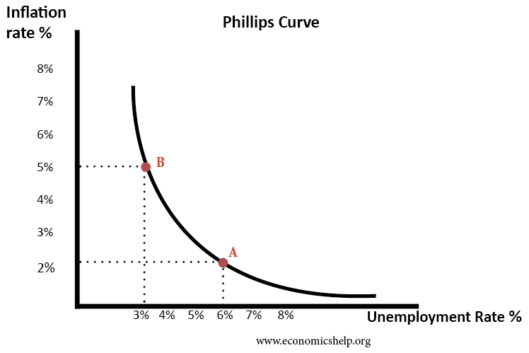

Governments, when injecting money into the market to reduce unemployment, would accept a slight increase in inflation, or vice versa. However, the oil shocks of the 1970s and Nixon's decoupling of the dollar from the gold standard in 1971 (the collapse of Bretton Woods) shattered this balance. The economy both stagnated (growth stopped and unemployment increased) and simultaneously, prices skyrocketed (inflation). This was a nightmare for governments; because if they spent to end unemployment, inflation worsened, and if they tightened their belts to stop inflation, unemployment spiraled out of control. This "impossible solution" led to the loss of legitimacy of the "interventionist state" model, which until then had been the protector of society and the provider of housing. Neoliberal think tanks, like the owners of capital, used this crisis as an opportunity; arguing that the state's presence in the economy was the very cause of the crisis, they made the discourse of "the state should not build housing, should not regulate the market, and should lower taxes" mainstream.
The most insidious effect of this macroeconomic bottleneck on housing was that, with the devaluation of money, it sowed the seeds of capital's search for a "safe haven." In an environment where inflation reached double digits, wealthy individuals and large corporations with cash sought to protect the value of their money by investing in physical assets that would always be in demand. Real estate began to be seen as the most resilient shield against inflation. Therefore, the stagflation crisis was not only an "excuse" for the welfare state to cut social housing budgets, but also the trigger for a major shift in mentality where housing ceased to be a "right" and was coded as a financial "hedge against inflation."
As the state withdrew, capital, fleeing the uncertainty created by stagflation, began to covet the cheap, public lands and buildings that were previously accessible to the public. This situation shows that the housing crisis was not merely an economic consequence; it was a political choice that began with the transfer of ownership in the chaotic environment created by stagflation and the replacement of public benefit with "capital security."
In this context, it is crucial for delegates to understand this: States stopped building social housing not because they "ran out of money," but because the new neoliberal mindset that replaced the old system, which collapsed with stagflation, viewed handing over housing to the market as a "condition of efficiency." Without understanding this ideological shift, you might fall into the trap of thinking that today's exorbitant rents and financialization are simply "the greed of real estate agents"; whereas the issue lies in the structural foundations laid during those dusty and crisis-ridden years of the 1970s.
As a result, when states succumbed to this pressure and stopped building social housing, and privatized their public housing, a huge void was created. People still needed a home to live in, but the state was no longer providing them with one. This forced millions of working-class and middle-class citizens into the utterly ruthless embrace of the private real estate market. However, people's salaries were insufficient to buy these privately owned homes outright. This is the ultimate consequence of the collapse of the welfare state: people were forced to take on debt en masse to afford housing.
  - Deregulation of Financial Markets and the Rise of Shadow Banking
With the dismantling of the welfare state, and the transition of housing from a public service to a purely market-driven system, a significant technical obstacle emerged. Traditional banks, the ordinary banks where our money is deposited, are subject to very strict rules called capital requirements. These rules essentially state that a bank can only lend a certain amount of money for every penny it holds in its vault. By the 1980s, banks wanted to sell mortgages to everyone because it was very profitable; however, due to limited funds, they struggled to find the liquidity, or cash, needed to lend more. The process of deregulation, the removal of government oversight of the financial sector, to overcome this bottleneck gave rise to securitization, one of the greatest dark magics in financial history. Securitization is the process of taking a boring 30-year home loan from a bank and combining it with the debts of thousands of other people, transforming it into a stylish investment package, a financial asset, that can be bought and sold on international markets. In this way, the bank immediately gets its money back by selling your debt to someone else, and with that money, it immediately goes and lends to someone else.
This cycle is the first cog in the wheel that transformed the housing market from a local issue into a global money-printing machine. To manage this massive cash flow, a new structure has emerged in the “shadow” of the traditional banking system: Shadow Banking. Don't let this term scare you; shadow banks are actually made up of institutions like investment banks, hedge funds, and money market funds. They are called shadow banks because they are not subject to the strict government regulations, deposit insurance, or central bank rules that regular banks are obliged to. In other words, these institutions operate under the radar of central banks, making much riskier, more complex, and unregulated huge bets. After traditional banks securitize and package mortgages, the real giants that buy these packages are these shadow banks. The shadow banking system buys these mortgage packages, transforms them into even more complex derivative products, and sells them to wealthy investors all over the world. As a result, housing, which until then was merely a place for a family to live, has now been transformed into an abstract financial toy, bought and sold millions of times a day by shadow banks driven by their greed for trillions of dollars in profits, its value reduced solely to numbers.
The most devastating consequence of this system on housing is that housing prices are completely detached from the wages of local people. Previously, the price of a house was determined by how much the people living in that neighborhood earned (their purchasing power); however, with the introduction of the shadow banking system, the price of a house is now determined by how much return the "securitized package" of that house will provide to an investor on Wall Street. In economic literature, this can be called "financial colonization." Now, a resident of a neighborhood in Istanbul or New York has to compete not with their neighbor, but with trillion-dollar shadow bank funds on the other side of the world to buy or rent a house. As a result of this unfair competition, housing prices skyrocket at a rate that local people can never keep up with.
At this point, you may have some questions; let's address them before concluding this section. In the last part, we said that thanks to these shadow banks, houses are essentially transformed into investment instruments. You might be wondering, what exactly is an investment instrument?
What we call an investment instrument is essentially transforming your money into a tool instead of simply hoarding it, allowing it to grow on its own over time. Let's explain this with a very simple example: it's like buying a rare skin or collectible card in a computer game. If you buy that card not to play the game, but to sell it for a higher price later when its value increases and make a profit, then that card is now a kind of investment instrument for you. In the financial world, there are larger and more serious versions of these cards.
The first of these is stock, which is becoming a co-owner of a company; that is, you invest money in the success or failure of that company. You may have heard this concept from your family; sometimes companies can offer a portion of their shares to the public (IPO), so even ordinary people can share in a small portion of the company's profits. However, the concept that actually triggered the housing crisis is the bond. A bond, in its simplest form, is a debt instrument. Let's say a huge company or a large government wants to undertake a major project but doesn't have enough cash in its coffers. It says to the outside world, to the public or investors: “Give me 1000 dollar today, I will give you this bond, and in 5 years I will pay you back 1500 dollar.” For an investor, the logic of buying a bond is to lend their money to a safe place and receive a guaranteed interest income in return. In the housing crisis, mortgages distributed by banks actually function like bonds for investors; the investor buys your debt and pockets your monthly payments as profit.
Commodities, in essence, mean any tangible raw material. Besides precious metals like oil, gold, and silver, agricultural products such as wheat, corn, and coffee are all commodities. Normally, the logic of a commodity market is to protect those who will use these products (bakers buying wheat, factories buying oil, etc.) from price fluctuations. However, what we call financialization has transformed commodities into a market as well. An investor, even if they have never been to a field in their life, can buy the paper right to tons of wheat simply because they expect its price to rise. The financialization of housing merges precisely here: global capital has begun to see houses not as homes where people live, but as commodities that are bought, sold, and speculated upon, just like gold or oil. For an investor, there is no difference between a building with 100 apartments in a neighborhood and 100 barrels of oil; both are simply financial figures to be bought and sold at the right time. In other words, they are investment instruments.
We also mentioned derivative products above. A derivative is a contract whose value is tied to something else. Returning to our apple tree example, the apple tree (the house/mortgage) is the underlying asset. If you buy a bet on the price of the apples that the tree will produce two years later, instead of the apple tree itself, that's a derivative. The financial world takes the mortgages of thousands of people, puts them in a container (MBS, i.e., mortgage-backed securities), and writes all sorts of risk and reward bets (derivatives) on top of that container. This reaches a point where the total value of these imaginary bets (derivatives) circulating in the market becomes many times greater than the combined value of all the real houses, oil, and gold in the world. As a result, the reason the rent in your neighborhood increases isn't because the house is beautiful, but because a shadow bank on Wall Street has placed a "derivative bet" on the house's debt. This ruthless intersection of global politics and economics has transformed housing from a human right into a massive chip in the derivatives market.

  - The 2008 Global Financial Crisis: How Real Estate Became the Ultimate Safe Haven for Capital

The road to the 2008 crisis was paved with the financial system's desperate hunger to create new areas of profit. The first major flaw in the system was the uncontrolled distribution of Subprime Mortgages, loans given to individuals with low credit scores or unstable incomes. The underlying cause was the constant demand from global investors for new, high-yield financial packages. Once banks exhausted the pool of stable borrowers, they turned to those least likely to pay back their debts just to keep the machine running. These risky loans were then bundled through Securitization, a process where thousands of individual debts are combined into a single investment package, and marketed worldwide as gold-standard investments. However, in 2007-2008, when interest rates rose and housing prices finally hit a ceiling and began to drop, this massive gamble collapsed. As people defaulted on their loans, the trillions of dollars in Derivatives (complex financial bets placed on the value of those loans) suddenly turned into worthless paper. The financial system suffered a structural "heart attack," and while millions of ordinary citizens were being evicted, the state intervention that followed would transform housing into a permanent tool of global finance.
The response of governments and central banks following the crash initiated the hyper-financialization phase of housing. While states sacrificed public resources to provide Bailouts (financial rescue packages) to banks deemed “Too Big to Fail”, central banks implemented Quantitative Easing (QE), essentially pumping trillions of dollars of fresh cash into the market and slashing interest rates to zero. This is the most critical link in the chain actually: with interest rates at zero, massive investment funds and Private Equity firms (large companies that manage the wealth of the ultra rich) found that holding cash or keeping money in traditional bank accounts was no longer profitable. These massive flows of capital began searching for the most secure physical asset that could protect their value against inflation and would always have demand. This was the moment real estate was declared The Ultimate Safe Haven. Unlike stocks or currencies, housing was viewed as an indestructible fortress for wealth because, regardless of the economic climate, people would always need a place to live.
The ultimate and devastating result of this shift was that housing ceased to be a living space and became a financial vault. Large scale private equity firms, such as Blackstone, began purchasing tens of thousands of foreclosed homes in bulk at bargain prices. Neighborhoods that were once owned by individual families were suddenly transformed into corporate portfolios. This parking of global capital into residential real estate caused home prices and rents to detach completely from local wages. For these corporations, even leaving a house empty can be a profitable financial move because the home’s value on the balance sheet continues to rise as a speculative asset. Of course, the 2008 crisis did not end the financialization of housing. It turned homes into a global currency and transformed residents into modern day serfs paying rent to transnational entities. This systemic shift is key to realizing that today’s housing crisis is not a simple lack of supply. Indeed, it is a result of housing being held hostage as a speculative chip in a global casino.

- State Complicity and Market Power
  - The Influence of Real Estate Lobbying on Government Policies
Real estate lobbying is the most powerful engine driving the transformation of the state from a neutral arbiter into a service provider that optimizes capital accumulation. To understand this process, it's essential to grasp that lobbying is not simply a matter of persuasion, but an institutionalized political pressure mechanism. The real estate sector, using its immense capital power, finances the election campaigns of political parties; this leads politicians to become indebted to the sector even before taking office. At this point, you might want to exercise caution when speaking, even though we are trying to present the issue from the SOCHUM framework, that is, through humanitarian values. Since you are responsible for representing your countries, we strongly advise you to research your countries' ideological stances on real estate. Because, if we pay attention, the most concrete example of this cause-and-effect relationship is the manipulation of legislative processes through campaign financing, even before they begin. Decision-makers, in order to protect the interests of the massive funds that brought them to power, tend to legitimize laws that facilitate the financialization of housing, while labeling social housing budgets or tenant rights, which would protect broad segments of society, as obstacles to economic efficiency and generally shelving them. Of course, as we said, countries have different attitudes and policies on this matter, which is precisely why researching your country's perspective is essential.
Another of the most insidious and effective methods of these lobbying activities is the Revolving Door phenomenon. This concept refers to high-ranking bureaucrats or politicians, tasked with protecting the public interest, immediately joining the boards of real estate giants they lobbyed for, receiving high salaries, after leaving their positions. This completely eliminates ethical boundaries between public institutions and the private sector, creating a conflict of interest. As a result, state regulatory bodies fall under the influence of the companies they are supposed to oversee, a situation known in the literature as Regulatory Capture. When regulatory takeover occurs, housing policies are no longer based on the housing needs of citizens, but rather on maximizing the profit margins of real estate investors, in other words, the system is redesigned with a logic of purely profit-oriented system optimization. This hegemonic influence created by lobbying makes the state's responsibility in the housing crisis invisible by hiding it behind "market dynamics." Real estate lobbies, through the media and think tanks, construct a discourse that presents the commodification of housing as an inevitable consequence of modernization. Thanks to this discursive power, the withdrawal of states from the housing market and the complete surrender of the field to mega-corporations is imposed on society as a rational necessity of the free market. Ultimately, these lobbying activities become the biggest political obstacle to the constitutional guarantee of the right to housing as a human right; because the legislature has ceased to be a representative of the people and has become the national-level executor of real estate capital. Again, we reiterate that each country has different attitudes or criteria on this issue.

  - Tax Incentives, Subsidies, and Favorable Zoning Laws for Mega-Corporations
After lobbying activities prepare the political ground, the state, using its legal and financial power, begins to offer tangible gift packages that maximize the profit margins of mega-corporations. The first and most effective link in these packages is tax incentives. These tax breaks offered by the state to giant real estate companies under the pretext of attracting investment or creating economic vitality are actually defined in the literature as Tax Expenditure. This concept means that the state forgoes taxes that should go into its coffers, and technically, it is a hidden public aid to that capital. For example, corporate tax exemptions or property tax reductions provided to a company undertaking a massive residential project reduce the company's costs and increase its profits; however, this directly results in a decrease in the budget that the state can use for education, health, or genuine social housing projects. Of course, this does not mean that states should never help the private market under any circumstances. Because state support for the market in strategic areas (incentives, R&D support, etc.) is actually a reality of the modern economy. However, it is also interesting that while neoliberalism rejects state intervention in the economy, the state somehow still intervenes in the economy. Neoliberalism, in theory, advocates for the state to withdraw from the market by advocating laissez-faire, but in practice, it needs the power of the state more than ever to remove obstacles to capital. Of course, in one of the most important committees of the United Nations, SOCHUM, we cannot say: states should not help this company, they should not support that one. Ultimately, every state has its own sovereignty, and no state is superior to another. But ultimately, neoliberalism is not just an economic ideology; it is a living current that directly impacts human life.
The second leg of this process, subsidies, is when the state directly or indirectly assumes the cost of a commercial activity. In the housing market, this is usually seen as “supply-side incentives”. The state provides mega-corporations with cheap credit opportunities far below market interest rates or offers direct cash support in exchange for them building affordable housing. However, the fundamental misconception here is that the real beneficiaries of these subsidies are not the citizens, but rather the companies that own the projects. These companies, building these projects with state support, allocate only a symbolic number of housing units as affordable, while selling the vast majority at exorbitant prices, thus using public resources as leverage to accelerate their own capital accumulation. What we are actually asking the delegates to do is to investigate and distinguish which specific projects fall under this scope.
Zoning laws and their relaxation in favor of mega-corporations (favorable zoning) constitute the most strategic and spatial dimension of the issue. Zoning is a set of legal rules that determines how many floors can be built on which land in a city, and which areas will be designated as green spaces and which as commercial areas. Under neoliberal pressures, these laws are manipulated through methods such as upzoning. Land normally designated for low-density or public use can be declared a Special Project Area overnight through lobbying and political cooperation, making it suitable for skyscrapers or luxury shopping mall complexes. This situation geometrically increases the value (rent) of that land while disrupting the fabric of the neighborhood, leading to unbearably high tax and rent increases for the local population, and initiating a displacement process.
The combination of all these tools proves that the state has ceased to be a neutral regulator and has become an enabler protecting the interests of mega-corporations. Thanks to tax incentives, subsidies, and personalized zoning plans, market power is concentrated in the hands of a few giant companies with global capital. This situation creates an oligopolistic (dominated by a few giants) structure in the market; small-scale local entrepreneurs or non-profit housing cooperatives become unable to compete with these mega-corporations that have all the resources of the state behind them. As a result, urban space is violently redesigned not according to the housing needs of citizens, but according to the profit projections of these giant corporations, which are protected and grown by the state.
  - The Privatization of Public and Social Housing Developments
The privatization of public and social housing is one of the most radical and destructive stages in the neoliberal process that transformed the right to housing from a public service into a purely market commodity. To properly understand this process, it is necessary to first clarify the difference between public and social housing: Public housing consists of structures directly built and owned by the state, while social housing consists of housing areas allocated at affordable prices to a specific social group by non-profit organizations or municipalities. The privatization of these areas since the 1980s, that is, their transfer to private ownership and capital groups, is a systematic liquidation operation initiated by the state under the pretext of relieving budgetary burden and achieving efficiency.
The most important mechanism employed here, austerity measures, mandated the withdrawal of public resources from social spending, while labeling the maintenance and repair costs of the existing housing stock as an "inefficient cost" and presenting the sale of these structures to the private sector as the only solution. The fundamental driving force behind this wave of privatization is the state's shift from viewing housing as a social responsibility to an asset that can be converted into liquidity (hot money). Beginning with populist policies like Right to Buy, this process, while initially promising to make tenants homeowners, has in the long run led to the depletion of the public housing stock and the rapid flow of these homes into the speculative real estate market. Once privately owned, these homes are no longer subject to state rent control or social oversight mechanisms; this creates a domino effect leading to the rapid gentrification of those neighborhoods and the displacement of low-income families to the outskirts of the city.
Here, the Neoliberal Paradox reappears: while claiming to withdraw from the economy, the state actually restructures the market by gifting its vast real estate holdings to capital. The privatization of social housing is not merely a change of ownership of buildings, but also an ontological rupture in the concept of housing. In this process, the state, while transferring construction and management powers to mega-corporations through complex structures called Public-Private Partnerships, actually integrates a system that does not pursue profit margins into a machine that operates according to profit maximization. For these companies, social housing becomes merely a burden to be carried until they pocket the subsidies received from the state; when the time is up, these buildings are either demolished to be converted into luxury residences or put on the market at exorbitant prices. As a result, each public housing unit destroyed through privatization further solidifies the dominance of financial capital within the city, transforming housing from a constitutional right into a class privilege accessible only to those with sufficient financial means.

  - The Failure of Rent Control Mechanisms Under Neoliberal Pressures
Rent control mechanisms are a form of direct state intervention in the housing market through the implementation of legal price ceilings on rent levels or annual rent increases. However, under neoliberal hegemony, these mechanisms are systematically demonized as market distortions that supposedly undermine market efficiency. Neoliberal pressures, often exerted by powerful real estate lobbies, argue that rent caps act as a disincentivization for property owners to maintain their buildings or for investors to fund new housing projects. These actors often leverage the threat of capital flight, warning policymakers that state intervention in price discovery will drive away global investment, thereby forcing governments to weaken or entirely dismantle protective legislation.
To truly comprehend the structural nature of this failure, one must examine the deceptive technical loopholes such as Vacancy Decontrol. Under this system, once a tenant vacates a unit, any existing legal caps on the rent for that specific unit are lifted, allowing the landlord to reset the rent to market value. This creates a perverse incentive structure where property owners are motivated to harass or unjustly evict current tenants to capture higher profits. This often leads to the phenomenon of renoviction (eviction under the guise of renovation), where neoliberal legal frameworks allow even minor aesthetic upgrades to serve as a legal justification for bypassing rent controls and hiking prices exponentially. As the state deliberately weakens its oversight mechanisms, rent control laws that exist on paper become mere formalities that offer no real protection.
The failure of rent control mechanisms is not a mere economic imbalance, but a testament to the political complicity of the state, which has outsourced its protective functions to market actors. By adhering to the neoliberal narrative that “the free market will eventually find its equilibrium,” states abandon tenants to the mercy of mega-corporations and private equity funds. This shift represents a fundamental ideological choice: prioritizing the protection of private property and profit over the human right to adequate shelter. Ultimately, the collapse of effective rent control is not a glitch in the system; it is a calculated victory for a neoliberal logic that values capital accumulation over human dignity. The role of the state in this process is completed when it clears the way for capital by removing the very legal barriers (such as rent limits) that were originally designed to protect the most vulnerable citizens.
- The Humanitarian and Social Fallout
  - Forced Evictions and the Surge in Global Homelessness
Under the prevailing neoliberal hegemony, the aggressive financialization of housing has fundamentally mutated the concept of shelter from an inalienable human right into a hyper-commodified speculative asset, directly precipitating a global crisis of forced evictions. As private equity firms, corporate landlords, and Real Estate Investment Trusts (REITs) increasingly monopolize urban housing markets, the maximization of shareholder value has violently superseded tenant security. This paradigm shift has triggered rapid gentrification, predatory purchasing practices, and speculative rent hikes, systematically pricing low and middle-income demographics out of their historical neighborhoods. When housing values are tethered to volatile global capital markets rather than localized income levels or community needs, systemic displacement becomes a structural inevitability rather than a mere market anomaly. Furthermore, the deliberate deregulation of tenant protections, coupled with the systemic dismantling of state-sponsored social housing programs, has left vulnerable populations at the absolute mercy of profit-driven market forces. Consequently, the contemporary surge in global homelessness is not an accidental byproduct of isolated economic downturns, but rather a direct, engineered consequence of state-sanctioned eviction machineries that prioritize property rights, asset appreciation, and capital accumulation over human dignity. This systematic erosion of the right to adequate shelter disproportionately ravages marginalized communities, abruptly severing their socio-economic safety nets, disrupting access to education and employment, and plunging millions into cyclical, intergenerational poverty. So, to sum everything up, the normalization of mass evictions exposes the profound humanitarian failure of treating essential living spaces purely as financial derivatives, stripping individuals of their ontological security and right to the city.

  - Hostile Architecture and the Criminalization of the Unhoused
All urban design and architecture is implemented with a particular goal in mind — often to shape people’s behavior in a particular direction. Hostile architecture, also known as unpleasant or exclusionary architecture, or defensive urban design, is a type of design which “uses elements of the built environment to guide or restrict behavior,” particularly relating to elements that are intended to stop people from doing something. (Hudson, 2023)
Hostile architecture is an urban design strategy that uses elements of the built environment to direct or restrict specific behaviors, such as sleeping in public spaces, skateboarding, illegal substance use, urinating in public spaces, and loitering. Such design elements tend to target not only skateboarders but also individuals with limited access to private spaces, such as youth and those living in poverty. Hostile architecture is prevalent in urban areas around the world and has spread to suburban regions.
In Portland, Oregon, strategically placed bike racks and planter boxes line sidewalks to keep unhoused individuals from being able to camp or rest in those spaces. In New York City, architects were denied a bid to shrink the vestibule of a historic building now owned by Tom Ford to make the building “less likely to be occupied” by unhoused people. And, in Connecticut, House Bill 6400 was introduced to ban “hostile architecture” all together in public spaces. (The Neighbourhood Design Center, 2023)
Yet while much of the current focus on hostile architecture centers on controversy involving those experiencing homelessness, these design elements are rooted in historic inequities and have been implemented in every area from landscaping to street planning in cities around the globe. The ideals driving the practice insidiously reinforce segregation, disinvestment and inequity across the American landscape. (The Neighbourhood Design Center, 2023)

Image taken by a Wikipedia User, Docteur Cosmos in 13 July 2011
The interplay of hostile architecture and the criminalization of homelessness within the context of urban space design and local regulations constitutes one of the most complex and controversial dilemmas of modern city planning. On the one hand, local governments, city planners, and commercial actors resort to defensive design strategies to maximize the functionality, safety, and aesthetics of public spaces. The division of seating areas with metal armrests, the placement of pointed concrete spikes under bridges and ventilation grilles, the sloping surfaces at bus stops, and the use of high-frequency sound emitters in certain areas are rationalized as legitimate public order tools to maintain the commercial vibrancy of city centers, ensure public health and hygiene standards, and address residents' security concerns.
When these physical barriers are supported by strict local laws prohibiting camping, begging, sleeping in vehicles, or prolonged loitering in public spaces, an integrated urban policy vision emerges that aims to maintain order in the streets. However, on the other hand, human rights advocates, urban sociologists, and civil society organizations sharply criticize this two-pronged strategy as a systematic mechanism of exclusion, marginalization, and punishment. According to this analytical perspective, hostile architecture and concurrently implemented anti-homelessness laws focus on erasing the victims of the problem from public visibility, rather than addressing the underlying macroeconomic problems of the housing crisis, such as insufficient social housing supply, income inequality, or the collapse of mental health services.
Defining biological survival practices unavoidable for homeless individuals, such as sleeping or resting in public spaces, as crimes or misdemeanors in the legal sphere, pushes these individuals into a vicious cycle of unaffordable fines, constant police intervention, and arrests. Therefore, these practices not only deprive the most vulnerable groups of their last physical refuge but also profoundly undermine the universal concept of the right to the city by framing urban poverty as a threat to public safety. Consequently, this phenomenon is central to global public policy debates about whether cities should be managed as sterile showcases catering only to a specific socioeconomic group, or as social ecosystems that provide structural, inclusive, and rehabilitative solutions to the housing and existential crises of disadvantaged citizens.

  - Disproportionate Impacts on Marginalized Groups, Migrants, and Minorities
The rampant financialization of the housing market does not impact all demographics equally; rather, it acts as a potent threat multiplier that exacerbates existing structural inequalities and disproportionately devastates marginalized groups, ethnic minorities, and migrant populations.
This disproportionate humanitarian fallout not only deepens the spatial and economic divide within urban centers but also systematically strips minority and migrant populations of their agency, perpetually confining them to perilous living environments at the extreme margins of society barriers (including deeply entrenched institutional racism, discriminatory zoning policies, and a systemic deprivation of generational wealth) rendering them acutely vulnerable to exponential rent hikes and forced displacements. Concurrently, migrants, refugees, and asylum seekers endure profound marginalization within the hyper-competitive private rental sector. Due to their precarious legal statuses, language barriers, and exclusion from state-subsidized social protection schemes, these demographics frequently fall victim to xenophobic discrimination, exploitative landlords, and severely substandard living conditions. For undocumented individuals, the persistent threat of deportation creates a pervasive chilling effect, effectively stripping them of the capacity to report housing rights violations, demand basic maintenance, or resist illegal evictions. Consequently, the unchecked commodification of shelter creates a vicious, self-perpetuating cycle of socio economic disenfranchisement, where the fundamental right to adequate housing is rigidly gatekept by structural biases. This disproportionate humanitarian fallout also systematically strips minority and migrant populations of their agency, perpetually confining them to perilous living environments at the extreme margins of society.

  - Gentrification as a Tool of Demographic and Political Displacement
Often softened in mainstream discourse under the guise of urban revitalization or neighborhood redevelopment, gentrification functions in practice as a calculated mechanism of demographic and political displacement. Driven by the relentless influx of speculative capital into historically underdeveloped and working-class neighborhoods, this process orchestrates the systematic eviction of former residents through exponential increases in property taxes, rents, and the overall cost of living. However, the consequences of this neoliberal spatial restructuring extend far beyond mere physical displacement; gentrification fundamentally functions as a profound instrument of political disenfranchisement. By geographically dispersing tightly knit, historically marginalized communities, the collective political activism, concentrated voting blocs, and grassroots mobilization capacities of these demographic groups are deliberately fragmented. This dispersion effectively disables their ability to elect representative local officials, influence municipal decision-making processes, or organize collective resistance against policies that perpetuate socio-economic inequality.
Gentrification, as we call it, is actually one of the biggest reasons or motivations for the homeless-hostile architecture we mentioned above. Here too, there is an intention to suggest that the streets and the environment should belong only to a certain segment of society, making it impossible for minority groups who lack access to this to exist within the community. The question of who should decide who can and cannot exist in society is quite controversial and perhaps even aggressive, but the real question is: how justified is it to declare that those without money cannot exist in society?
Consequently, the overall urban agenda utilizes gentrification not merely as a motor for capital accumulation, but as a strategic method for reshaping the demographics of urban centers. By diluting the electoral power of minorities and replacing the working-class population with an affluent, politically compliant demographic, state and corporate actors secure sustainable political hegemony. Ultimately, the systematic transformation of diverse neighborhoods into privileged zones transforms urban geography into a tiered citizenship system where meaningful political participation and the "right to the city" are inextricably linked to immense economic privilege.

- Global Dynamics and Bloc Perspectives
Before examining the global dynamics and the attitudes and behaviors of countries regarding this agenda, we need to look at what global statistics say. Let's examine some statistics based on OECD countries.
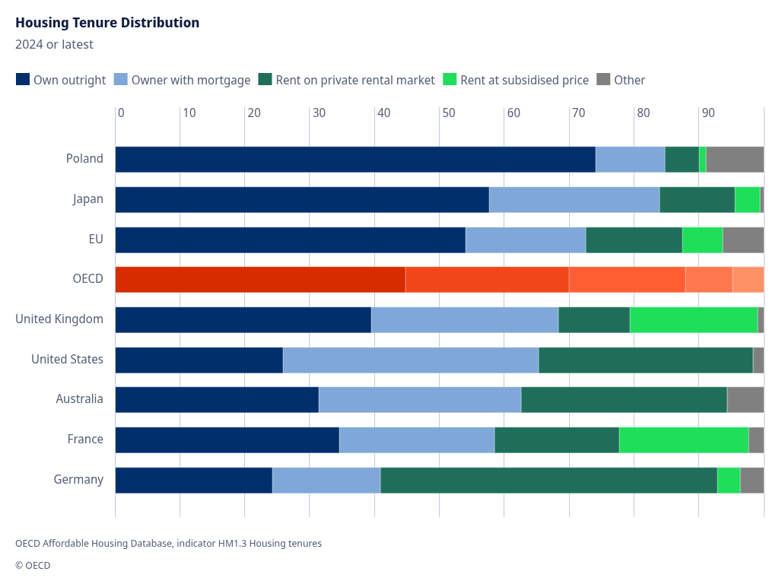
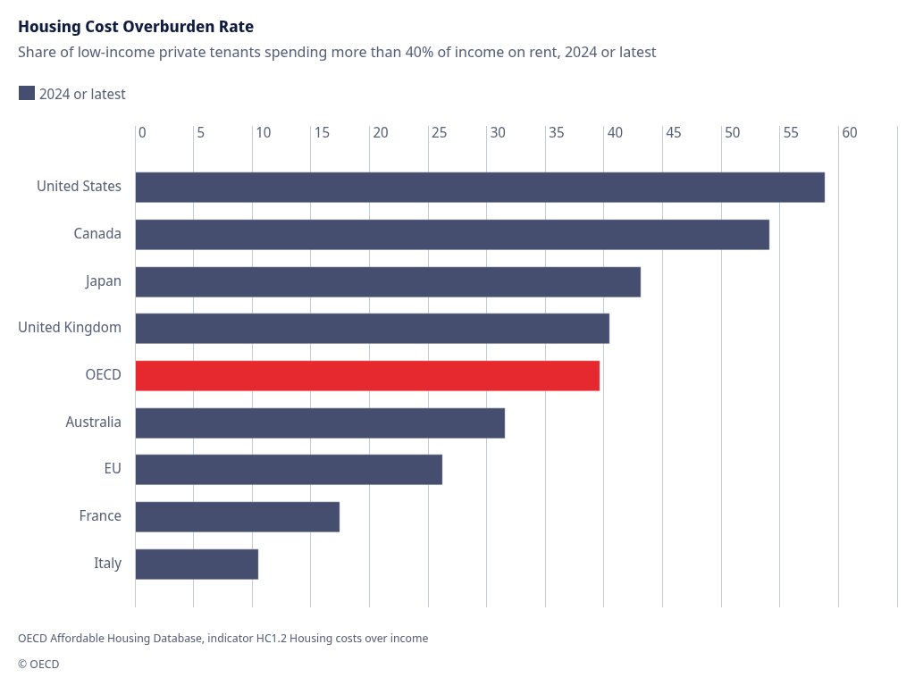
This graph reveals the human cost of the neoliberal housing model by showing overburden rates where low-income private tenants allocate more than 40% of their income to rent. In the literature, the 40% threshold is considered a critical point where a household begins to compromise on basic needs such as food, healthcare, and education due to housing costs. Analysis of the data shows that countries at the heart of the neoliberal economic model, such as the United States (~58%) and Canada (~53%), have the highest rates; this is directly related to the fact that the share of social housing stock in total housing remains below 10% in these countries. Furthermore, these high rates are a consequence of rent control measures in countries like the US being limited to certain major cities rather than being a national policy. In contrast, overburden rates in countries like Italy (9%) and France (16%) remain well below the OECD average of 39%, demonstrating the effectiveness of protective mechanisms. France maintains a medium-sized social rental sector representing 14% of its housing stock and spends 0.21% of its GDP to support this sector. Italy, on the other hand, balances market pressure by using regulated contracts that limit rent increases through mutual agreements between tenant and landlord organizations in densely populated areas. However, the general global trend shows that these protective systems are eroding; in the last decade, the share of social housing stock has decreased in 18 of the 25 OECD countries. The main reason behind this decline is that the share of public financing for social housing in GDP was higher in 2010 than it is projected for 2022, and government spending is failing to keep pace with economic growth.
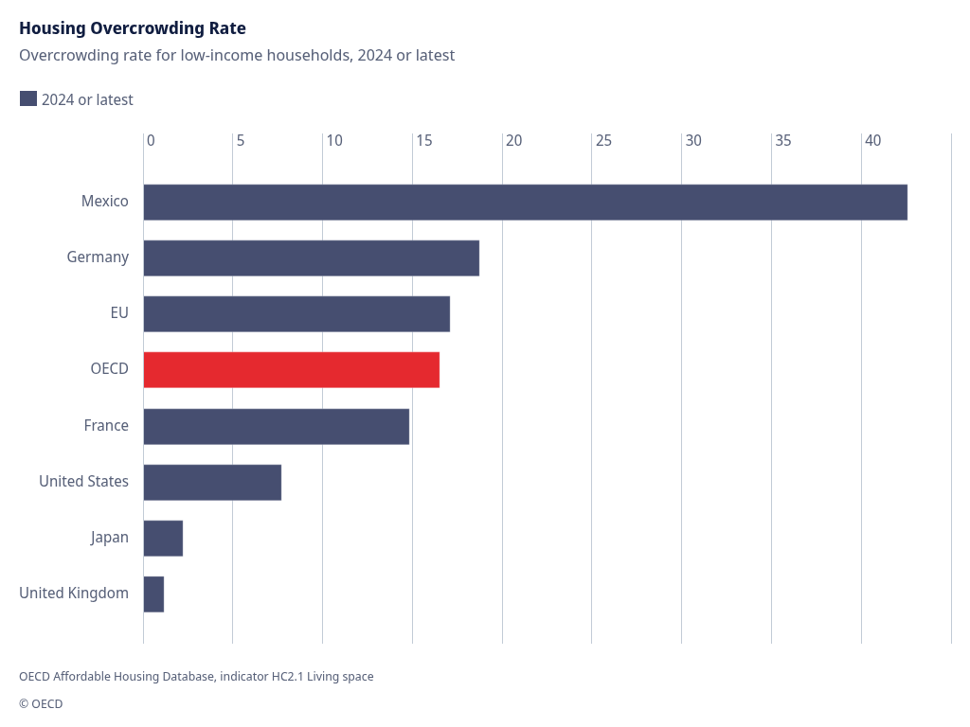
This graph provides a comparative overview of housing regimes and ownership structures across countries, painting a deep socio-economic picture of whether housing is viewed as a right or an investment. Analysis of the data reveals that in post-socialist countries like Poland, owning outrights are dominant, exceeding 70%; while in countries like Germany, the rent-on-private rental market has become the primary form of housing, accounting for approximately 50%. Despite Germany's "tenant nation" profile, the social rental housing sector represents a relatively small share of the total housing stock, remaining between 2% and 10%. On the other hand, in neoliberal economies such as the United States and Australia, ownership is largely based on owner-with-mortgage; this makes household housing security directly vulnerable to fluctuations in financial markets and interest rates. One of the most critical indicators in the graph, rent at subsidized price, symbolizes the strength of institutional protections developed by countries against housing crises. France and the United Kingdom exhibit a more balanced profile in this area, with medium-sized social housing sectors ranging from 10% to 19%; while in the US and Australia, this ratio remains marginal, between 2% and 10%. The reliance of social rental housing on specific allocation rules and sub-market prices rather than market mechanisms serves as a vital safety net for low-income groups. However, as we have seen in previous data, the share of social housing stock has decreased in most OECD countries over the last decade; this has been triggered by privatization processes such as the conversion of rental housing into market-priced housing or its purchase by tenants and subsequent transfer to private ownership. Consequently, this picture reflects the level of financialization of housing and the role of governments in this process. In countries like the United Kingdom, the sharp reduction in local government investment in new social housing construction has paved the way for the expansion of private rental and mortgage-backed ownership areas as shown in the graph. The government's focus on subsidizing the private market instead of directly providing housing leads to the allocation of public resources to temporary solutions rather than creating permanent housing stocks.
This graph shows that the housing crisis is not just a matter of wallets, but also a battle for physical space worthy of human dignity. The Housing Overcrowding Rate documents how many low-income households are forced to live in substandard housing, meaning insufficient rooms per person. The most striking point to understand this data is that Mexico is clearly at the top with a rate approaching 42%; this is directly related to the fact that Mexico has almost no publicly owned rental housing sector and social housing is only offered to very limited groups, such as military personnel. The state's withdrawal from the social housing stock not only increases rents but also systematically reduces the quality of life for low-income groups by confining them to very cramped spaces.
The graph also shows that Germany (18%) is above the OECD average (15%), proving that even in a country known as a tenant nation, low-income groups do not have access to sufficient space. Although Germany has implicit subsidies such as exemptions from property and land taxes, the structural cause of this overcrowding is the decrease in the social housing stock from 2010 to 2022 and the privatization of the existing stock by converting it into market-priced rental housing. On the other hand, the lower rates in countries like the UK (1%) and Japan (2%) may be due to their strict regulations on living space standards. For example, in the UK, it is a legal requirement that all housing be free from serious hazards, including overcrowding.
In conclusion, if you understand this picture, you can see that the housing crisis is not just an economic statistic, but also a matter of public health and social justice. France's rate (14%), close to the OECD average, shows that despite allocating 0.21% of its GDP to social housing, the pressure on low-income households continues. This is a result of government spending not keeping pace with the rate of economic growth. Neoliberal policies, which have slowed social housing construction and led to the privatization of existing stock, are condemning low-income households to either pay more than half of their income in rent or live in overcrowded environments that threaten human health.
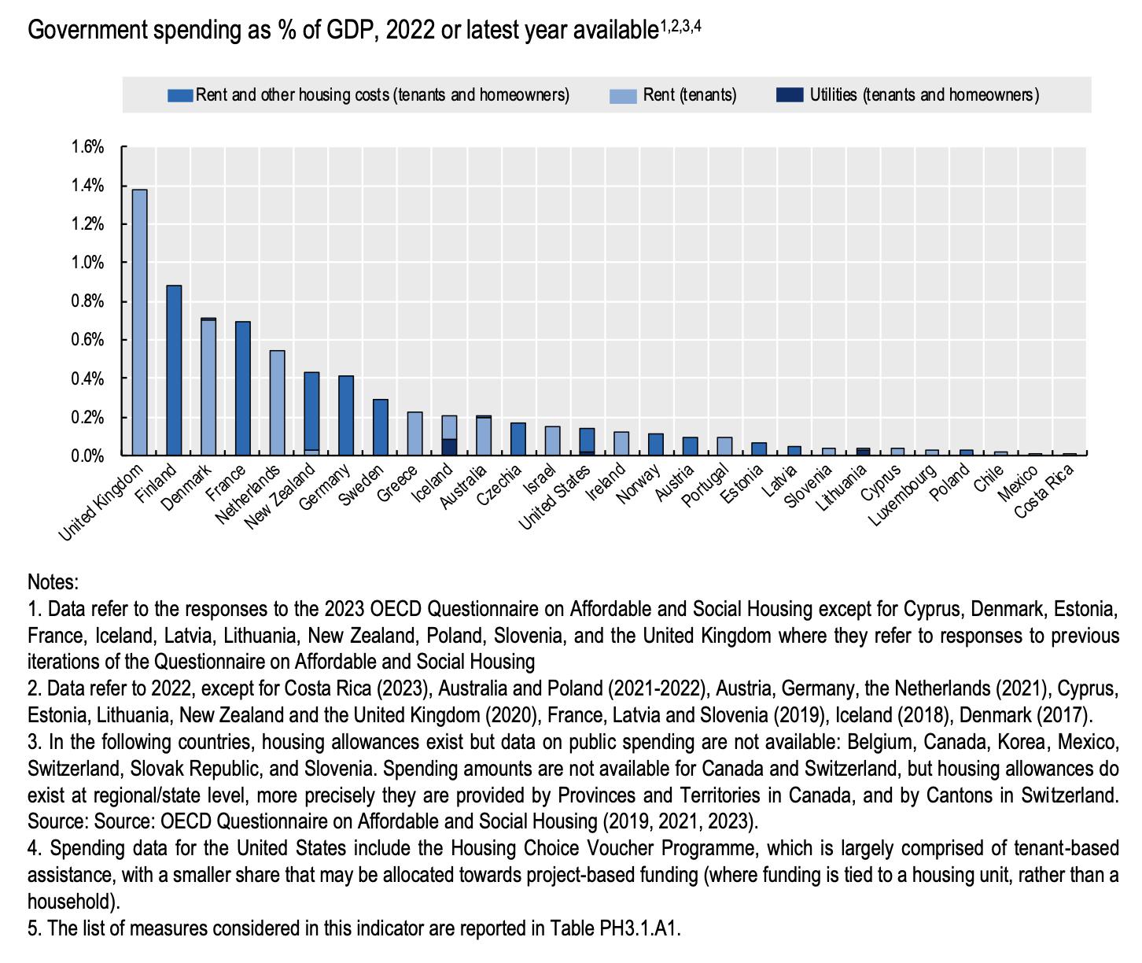
This table analyzes, on a GDP basis, public spending allocated to personal subsidies such as housing allowances, rather than directly producing public housing. The data shows that countries like the United Kingdom (approximately 1.4%) and Finland (~0.9%) have the highest spending in this area, followed by France and Denmark at around 0.7%. The fact that a large portion of this spending goes directly to "rent" indicates a wealth transfer mechanism where public resources are channeled directly to private property owners and real estate funds instead of creating a permanent social housing stock.
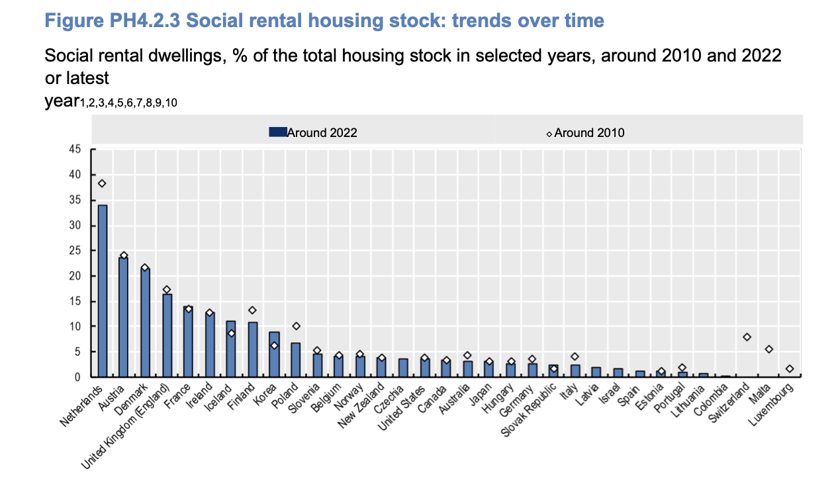
In the specific cases of countries like Ireland and New Zealand, this data also includes amounts paid directly to landlords to bridge the gap between rent and the tenant's ability to pay. This demonstrates that, in the process of the financialization of housing, the state has shifted from being a provider to a subsidizer guaranteeing the profit margins of market actors through the public budget. In countries like the US (~0.1-0.2%), which are part of the neoliberal core, these rates remain much lower, explaining why low-income tenants are burdened with excessive costs, having to pay more than 40% of their income in rent. The shift in government spending from social housing construction (physical stock) to such personal cash assistance is a consequence of removing housing from being a permanent public asset and making it entirely dependent on market dynamics.
This graph provides one of the most concrete data points on the financialization of housing, showing the temporal change in the share of social rental housing stock within the total housing stock from 2010 to 2022. An examination of the data reveals that in 18 out of 25 OECD countries, the share of social housing decreased in the last decade. Countries such as the Netherlands, Finland, and Poland experienced the sharpest decline, with losses exceeding 2 percentage points; while Austria, Germany, Italy, Norway, and the United Kingdom saw decreases ranging from 0.25 to 2 percentage points.
To understand this general downward trend, it is necessary to look at three main turning points within the system: the slowdown in new social housing construction, the privatization of the existing stock, and the inability of public spending to keep pace with economic growth. For example, in Germany, the privatization of social housing by converting it into market-priced rental housing, and in the United Kingdom, the transition of tenants to owning properties by purchasing their homes, are fundamental structural reasons for this decline. Throughout this process, the fact that the share of public spending on social housing as a percentage of GDP remained lower in 2022 compared to 2010 in all countries for which data is available proves that the state has also withdrawn financially from its responsibility for housing. Although a stock increase of more than 2.5% was seen in rare countries such as Iceland and Korea, the general global trend confirms that housing is being removed from the realm of public rights and handed over to market dynamics.

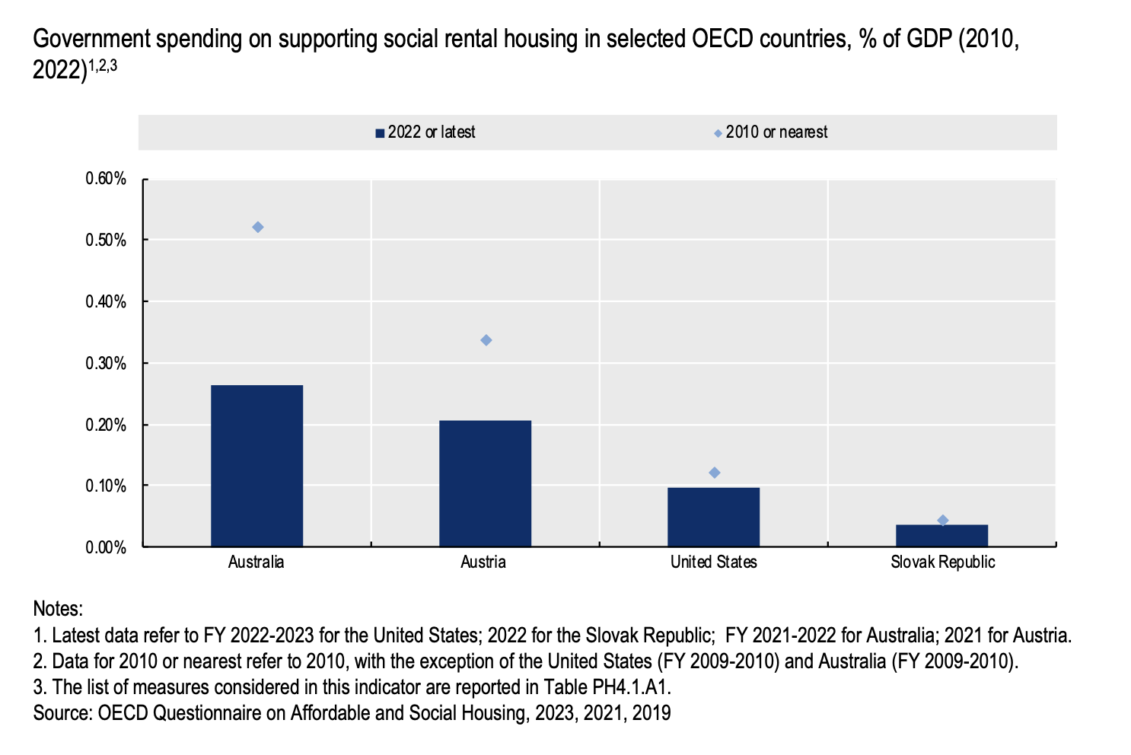

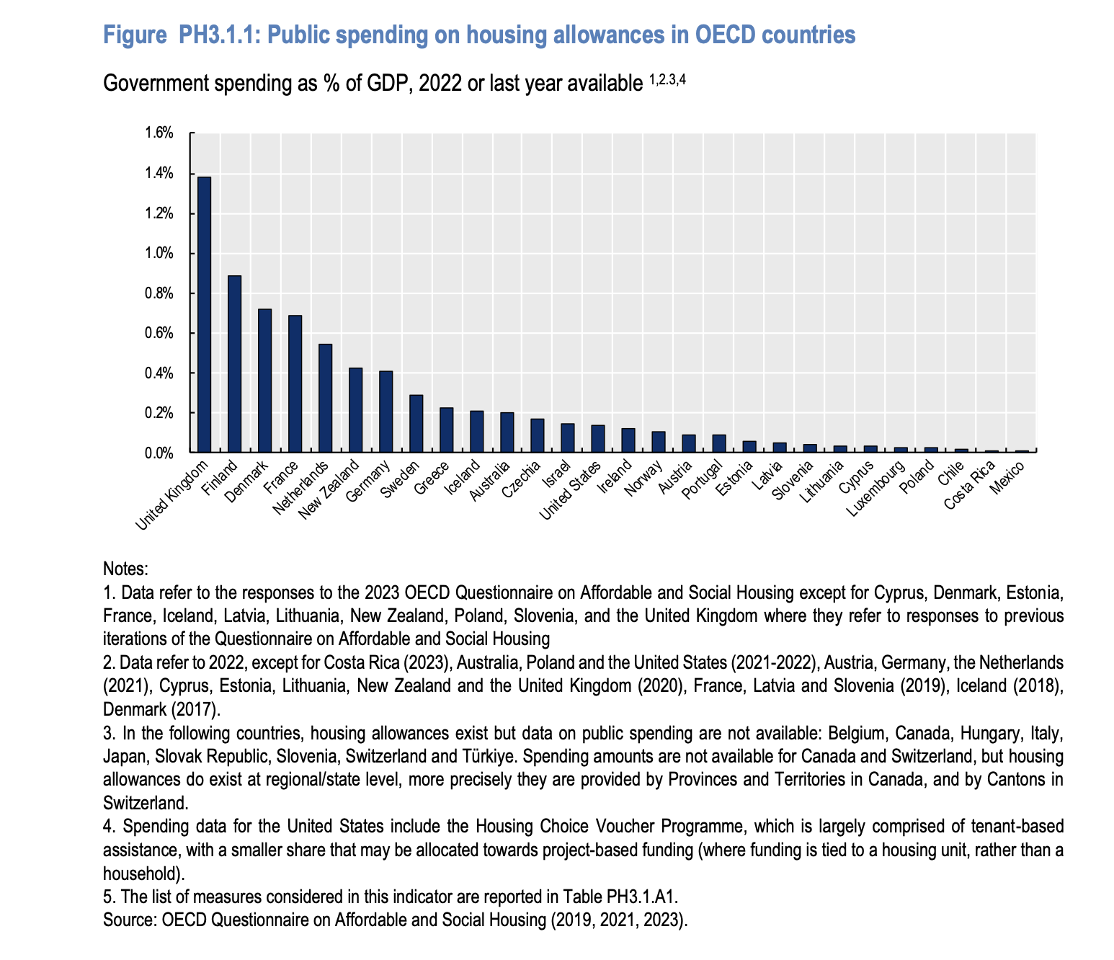
We would also like to present you with some different data that we have obtained from OECD reports. Social rental housing, theoretically defined as accommodation provided at sub-market prices and allocated through specific non-market rules, is currently undergoing a managed decline across the global stage. While the EU and OECD maintain average stocks of 8% and 7% respectively, totaling roughly 28 million dwellings, these numbers mask a massive geographic and ideological divide. On one side, the "socially oriented" bloc of Austria, Denmark, and the Netherlands maintains stocks exceeding 20%; on the other, the neoliberal core of the USA, Canada, Germany, and Australia survives on a meager 2% to 10%. It is crucial for you to understand that even these figures are shrinking; in the last decade, 18 out of 25 OECD countries saw their social housing share evaporate due to construction slowdowns and active privatization. In the UK, this manifests as tenants purchasing their social units, while in Germany, social stock is being systematically converted back into market-rate rentals. Interestingly, Türkiye remains outside these specific rental statistics because its social housing model prioritizes subsidized homeownership over rental stock.
This physical erosion is fueled by a profound fiscal retreat; public spending on social housing as a share of GDP was higher in 2010 than in 2022 in every single reporting country. As economies grew, housing investment was left in the dust, most notably in Australia, where spending halved. Even in the spending leaders like New Zealand (0.35% of GDP) and France (0.21%), the majority of nations now spend less than a symbolic 0.1%. To truly comprehend this shift, we must look at the marketization of finance. Providers are being pushed away from direct public funding toward private capital, bond markets, and revolving funds where current tenants' rents must fund future units. The Netherlands serves as the ultimate case study of this paradox: despite having the highest stock share, it has provided zero direct public spending for social housing provision since 1995, relying instead on state-backed guarantees for private loans. This financial camouflage is further aided by hidden subsidies like VAT reductions and tax exemptions, which remain largely unreported in most countries except France.
The regulatory environment exacerbates this crisis by offering an illusion of protection while facilitating cost pass-throughs to tenants. Only 14 countries control initial rent levels, and even strong systems like Germany's allow a 10% markup over local benchmarks in tight markets. Most alarmingly, 22 countries allow landlords to pass the costs of maintenance, upgrades, and energy-efficiency improvements directly onto the tenant, effectively making the poor pay for the appreciation of the landlord's asset. Termination laws also favor capital; 24 countries allow renoviction (termination for renovation), and 15 countries allow eviction if the landlord simply decides to sell the property. While the COVID-19 pandemic saw a brief surge in tenant protections, such as eviction bans in Canada and rent freezes in Türkiye, Colombia, and Luxembourg, most have been phased out, replaced by targeted but limited aids like Austria’s cost of living grants or Ireland’s 2% rent caps. Meanwhile, the cannibalization of long-term stock by platforms like Airbnb remains largely unchecked; only 16 countries regulate short-term rentals, and nations like Italy even offer a 21% substitute tax rate, providing a financial incentive for tourism over permanent residency. Consequently, the data reveals a world where the state has transitioned from a provider of shelter to a secondary guarantor of private real estate profit.
Now let's look at the country blocs and their positions.
1. The Neoliberal Core: Financialization Architects
(United States of America, United Kingdom, Canada, Australia, Ireland, New Zealand)
This bloc is both the creator and the primary exporter of the global housing crisis. In these countries, neoliberalism isn't just a state policy; it is the state's raison d'être. Housing is the primary investment vehicle for Wall Street, the City of London, and massive Real Estate Investment Trusts (REITs). Housing policies in the US and the UK focus on deregulating the private sector under the guise of increasing supply. Meanwhile in Canada, Australia, and New Zealand, the housing market has become the sole engine sustaining the national GDP. Ireland acts as the “Trojan horse” of this bloc in Europe; it attracts Big Tech and finance with low corporate taxes while condemning its own citizens to a horrific housing crisis. This bloc's main strategy in the committee will be to blame the crisis on a lack of supply and restrictive zoning, rather than acknowledging the flaws of the financial system itself.
2. The Eroding Welfare States: The European Struggle
(Germany, France, Sweden, Norway, Denmark, Finland, Iceland, Belgium, Netherlands, Luxembourg, Switzerland, Austria)
Historically the bastions of the welfare state, these countries are now fighting a life or death battle against the neoliberal wave. They still theoretically define housing as a human right on paper. However, the reality on the ground is different: in Sweden, debates over transitioning to market-oriented rent systems routinely topple governments, while in Germany, the takeover of the market by giant real estate funds (like Deutsche Wohnen) has pushed the public toward radical expropriation referendums. Austria (especially with its Red Vienna model) and France try to protect their social housing stock, but budget cuts and EU austerity policies are eroding these shields. This bloc's dilemma in the committee is that they are trapped between their human rights rhetoric and the profit expectations of global finance.
3. High-Growth Asian Countries: Demographics and Density
(Japan, South Korea, Singapore, Malaysia)
This bloc is characterized by massive populations squeezed into tight geographic areas, driven by state-sponsored hyper-capitalism. Singapore offers one of the world's most successful social housing models by housing 80% of its population in state-built flats (HDB), though this relies on a strict, state-controlled property regime. South Korea grapples with “Jeonse” (a unique and highly speculative financial lease system where tenants pay a massive lump-sum deposit instead of monthly rent), while Japan faces the “Akiya” (abandoned homes) crisis due to an aging population and shrinking demand. In the committee, these delegates will tend to advocate for technological solutions, smart cities, and dense vertical construction, largely ignoring the underlying "class" dimension of the crisis.
4. The Debt-Burdened Global South: Informality and IMF Chains
(India, Philippines, Kenya, Nigeria, Bangladesh, Pakistan, Indonesia, Vietnam, Egypt, Morocco, Brazil, Mexico, Argentina, Colombia, Chile, South Africa, Peru, Ecuador, Uruguay, Rwanda, Senegal, Uganda, Nepal, Myanmar, Thailand, Cambodia, Sri Lanka)
This is the most populous and victimized bloc at the table. The housing crisis here isn't just about rising prices; it means massive slums and favelas expanding on the peripheries of megacities, a severe lack of infrastructure, and violent forced evictions. Countries like Argentina and Brazil struggle with chronic inflation and foreign debt spirals, having been forced to slash their social housing budgets due to IMF structural adjustment programs. In India, Nigeria, and Egypt, the state builds luxury "new capitals" or gated communities for foreign investors while pushing its own poor out of the market (expulsion). These delegates will present fiery arguments centered on the "right to development," "neocolonialism," and "fiscal sovereignty," placing the blame for the housing crisis squarely on the financial dictates of the Global North.
5. State-Capitalist & Geopolitical Heavyweights
(People's Republic of China, Russian Federation, Iran, Kazakhstan, Venezuela)
In this bloc, neoliberalism operates strictly under authoritarian state control. China drove massive economic growth through the state-encouraged financialization of housing, only to witness the bursting of this real estate bubble with the Evergrande crisis. It is now trying to course-correct under the mantra, "Housing is for living in, not for speculation." In Russia and Iran, the real estate market serves as a safe haven for oligarchs and regime-affiliated elites to park their wealth under the pressure of heavy international sanctions. Venezuela, in the midst of a profound macroeconomic collapse, uses housing as a tool for state propaganda (e.g., the Great Housing Mission). This bloc will actively reject the West's "free market" impositions and argue that "strong state intervention" is the only valid solution to the housing crisis.
6. The Rentier States & Safe Havens
(Saudi Arabia, United Arab Emirates, Qatar, Malta, Cyprus)
For these countries, housing is not primarily a means of shelter; it is a magnet used to attract global capital, petrodollars, and offshore wealth. The UAE (Dubai) and Saudi Arabia (with mega projects like NEOM) have made the construction sector the ultimate showcase of their diversified economies. Malta and Cyprus have become Europe's backdoors through “Golden Visa” (citizenship by investment) programs, rendering local housing completely unaffordable for their own citizens. In the committee, this bloc should fiercely oppose any pushes for financial transparency and global tax regulations, staunchly defending the sanctity of foreign investment.
7. The Crisis-Prone Periphery & Post-Socialist Transition
(Republic of Türkiye, Italy, Greece, Spain, Portugal, Poland, Estonia, Latvia, Lithuania, Czech Republic, Romania, Ukraine, Serbia, Croatia, Hungary, Bulgaria)
This bloc is a hybrid comprising Southern European nations devastated by the debt crisis and Eastern European post-socialist states. Italy, Spain, Greece, and Portugal saw international “vulture funds” swoop in to buy up distressed housing stock after the 2008 financial crisis, and locals are currently being driven out of city centers by platforms like Airbnb. Poland, Hungary, and the Baltic states boast extremely high outright ownership rates (70-90%) because post-Soviet housing was practically given away to the public; however, housing quality is incredibly low, and finding a rental for the younger generation is nearly impossible. Türkiye represents the most extreme example in this group, where real estate is aggressively used as a hedge to protect wealth against chronic inflation. Because they remain dependent on EU and Western finance, these countries won't be able to offer radical systemic solutions in the committee; instead, they will demand symbolic regulations to appease public anger back home.
(Note: If you've read this far, please send me an email. You can send anything – a question, anything – or just a greeting! My email address is at the beginning of the guide, “Letter from Under-Secretary General”.)

8. International Legal Framework and Its Political Limitations
8.1. The Evolution and Scope of the Right to Adequate Housing
The right to adequate housing has long been embedded within the broader framework of international human rights law, emerging as a response to the recognition that shelter is not merely a commodity, but a prerequisite for human dignity and security. Foundational documents such as the Universal Declaration of Human Rights (1948) and the International Covenant on Economic, Social and Cultural Rights (1966) articulate housing as an essential component of an adequate standard of living. Over time, this right has been further clarified to include not only physical shelter, but also legal security of tenure, affordability, accessibility, habitability, and access to basic services.
However, despite this expanded definition, the scope of the right remains contested. States often interpret their obligations in minimalistic terms, reducing housing to a question of availability rather than adequacy. This narrow interpretation allows governments to claim compliance while large segments of their populations continue to face housing insecurity, displacement, or exclusion from urban spaces. As a result, the evolution of the right to housing reflects a tension between its expansive theoretical definition and its limited practical application.
8.2. The Role of International Institutions: Standard-Setting vs. Enforcement
International institutions, particularly within the United Nations system, play a central role in defining norms, monitoring state behavior, and shaping global discourse on housing rights. Bodies such as UN-Habitat and the Office of the High Commissioner for Human Rights (OHCHR) have been instrumental in promoting the understanding of housing as a human right rather than a market asset. Additionally, Special Rapporteurs on adequate housing provide detailed country reports, identify patterns of violations, and offer policy recommendations.
Despite these contributions, the influence of international institutions is largely limited to standard-setting and advocacy. Their inability to impose binding sanctions or enforce compliance significantly weakens their effectiveness. Unlike international financial institutions, which can exert pressure through conditional lending, human rights bodies rely primarily on moral authority and diplomatic engagement. Consequently, their recommendations are often sidelined when they conflict with national economic priorities or powerful domestic interests.
8.3. Structural Limitations: Sovereignty, Market Forces, and Selective Compliance
One of the most significant challenges in enforcing international housing rights lies in the principle of state sovereignty. Governments retain ultimate authority over domestic policy, including land use, housing regulation, and economic planning. While states may formally commit to international agreements, they frequently prioritize national economic strategies particularly those aligned with neoliberal principles over their human rights obligations.
This dynamic is further complicated by the growing influence of global financial markets. Housing has increasingly become an asset class, attracting investment from multinational corporations, private equity firms, and transnational capital flows. In such a context, states are not merely passive actors but active participants in facilitating housing financialization through deregulation, tax incentives, and privatization policies.
The result is a pattern of selective compliance, where states uphold international norms in rhetoric while undermining them in practice. This contradiction exposes a fundamental limitation of the current legal framework: without mechanisms to address the economic structures driving housing inequality, international law remains insufficient to ensure the realization of housing as a universal human right.
9. Case Studies in Political Action and Resistance
9.1. Grassroots Mobilization and the Reclaiming of Housing Rights
In the absence of effective institutional enforcement, grassroots movements have emerged as critical actors in challenging housing injustices. Across various regions, tenant unions, community organizations, and activist networks have mobilized to resist evictions, oppose rent increases, and demand greater state accountability. These movements often employ a combination of legal advocacy, public demonstrations, and direct action to contest the commodification of housing.
Beyond immediate resistance, such initiatives also play a transformative role in reframing the discourse around housing. By emphasizing housing as a social good rather than a financial asset, grassroots actors challenge dominant neoliberal narratives and propose alternative models rooted in equity and collective ownership. While their success varies depending on political and legal contexts, they consistently highlight the gaps left by state and international mechanisms.
9.2. State Responses: Reform, Regulation, and Their Limits
State-led interventions in housing markets provide a complex and often contradictory picture. In some cases, governments have introduced progressive policies aimed at improving affordability and accessibility, including rent control measures, expansion of public housing, and regulations targeting speculative investment. These initiatives demonstrate that state action can mitigate some of the adverse effects of housing financialization.
However, such reforms are frequently constrained by broader economic frameworks. Even as states implement protective measures, they may simultaneously promote policies that attract real estate investment and encourage market-driven development. This dual approach limits the long-term effectiveness of reforms, as underlying structural dynamics remain unaddressed. Consequently, state responses often alleviate symptoms rather than resolving the root causes of housing crises.

9.3. Comparative Insights: Successes, Failures, and Transferability
Examining global case studies reveals that alternative housing models can produce meaningful outcomes when supported by sustained political commitment and institutional capacity. Cities that have invested in large-scale social housing, cooperative ownership structures, or strict regulatory frameworks have demonstrated greater resilience against housing inequality and displacement.
Nevertheless, the transferability of these models remains a significant challenge. Policies that succeed in one context may not be easily replicated elsewhere due to differences in political systems, economic conditions, and social structures. Furthermore, increasing globalization and financial integration place additional pressure on local housing markets, limiting the autonomy of individual states or cities.
These case studies ultimately underscore a critical insight: while effective solutions do exist, their implementation requires not only technical policy design but also a fundamental re-evaluation of the relationship between housing, markets, and the role of the state.

10. Questions to be Addressed
- How can Member States implement robust regulatory frameworks to curb the predatory practices of corporate landlords, private equity firms, and Real Estate Investment Trusts (REITs) without completely destabilizing local economies?
- In what ways can the international community legally and practically enforce the paradigm shift of housing from a speculative financial commodity back to a fundamental human right?
- What standardized international or municipal guidelines should be established to dismantle hostile architecture and legally decriminalize the survival practices of the unhoused?
- By what mechanisms can the United Nations and its affiliated bodies hold both state and non-state actors (e.g., multinational real estate corporations) accountable for the systematic erosion of the right to adequate shelter?
- How can Member States systematically incentivize, fund, and transition towards non-market housing solutions, including state-sponsored social housing, community land trusts (CLTs), and housing cooperatives?
- What universal minimum standards for tenant protections (such as rent stabilization models, anti-eviction moratoriums, and extended notice periods) should be adopted to shield vulnerable populations from market volatility?
- What intersectional safeguards must be implemented to protect historically marginalized groups, ethnic minorities, and undocumented migrants from discriminatory real estate practices and disproportionate evictions?
- How can local and national governments mitigate the demographic and political displacement caused by aggressive gentrification while still encouraging sustainable urban infrastructure improvements?
- Given that contemporary macro-economies and national GDPs are profoundly dependent on the continuous growth, commodification, and financialization of the real estate sector, how can Member States systematically decouple the human right to shelter from the speculative demands of the free market without triggering systemic global economic destabilization?

11. References
Hudson, L. (2023, 11 December). Urbanism 101: Hostile architecture. The Urbanist. https://www.theurbanist.org/urbanism-101-hostile-architecture/
Neighborhood Design Center. (2020, 2 November ). Understanding hostile architecture: The cause and effect of restricting. https://ndc-md.org/news-and-stories/understanding-hostile-architecture-the-cause-and-effect-of-restricting
Kemp, Peter (2007) Housing allowances in comparative perspective, Policy Press University of Bristol
MISSOC - Mutual Information System on Social Protection, Comparative Tables Database
http://www.missoc.org
OECD (2021), Tax and Benefit Systems: OECD Indicators, http://www.oecd.org/social/benefits-and-wages.html
OECD (2021), “Building for a better tomorrow: Policies to make housing more affordable”,
Employment, Labour and Social Affairs Policy Briefs, OECD, Paris, http://oe.cd/affordable-
housing-2021 .
Salvi del Pero, A. et al. (2016), Policies to promote access to good-quality affordable housing in
OECD countries. OECD Social, Employment and Migration Working Papers, No. 176, OECD
Publishing, Paris. http://dx.doi.org/10.1787/5jm3p5gl4djd-en
Stephens, M., et al. (2010), Study on Housing Exclusion: Welfare Policies, Labour Market and Housing Provision. Brussels: European Commission.
Faber, D., & Schlegel, C. (2017). Give me shelter from the storm: Framing the climate refugee crisis in the context of neoliberal capitalism. Capitalism nature socialism, 28(3), 1-17.
Van Schaik, J. (2025). Arming the Homeless: The Evil Institution of the Canadian Austerity State (Doctoral dissertation, The University of Western Ontario).
Rolnik, R. (2020). Housing under the Empire of Finance1. In The Routledge handbook of financial geography (pp. 189-207). Routledge.
Sikka, P. (2015). The hand of accounting and accountancy firms in deepening income and wealth inequalities and the economic crisis: Some evidence. Critical Perspectives on Accounting, 30, 46-62.

Note: All data and graphs from part 7 to this point are taken from the OECD's Affordable Housing Database. https://www.oecd.org/content/oecd/en/data/datasets/oecd-affordable-housing-database.html. It is recommended that delegates from non-OECD countries conduct their own extra research.

