ICAO STUDY GUIDE HASALMUN’26

CONTENTS

Letter from the Secretary General 3
Letter from the Under Secretaries General 4
What is the International Civil Aviation Organization? 5
ICAO’s Rulemaking Process 6
Historical Context 7
a. Aviation in the 1980s 7
b. Reagan Administration 8
c. Soviet Regime 9
Incident: Korean Air Flight 007 10
Initial Flight 10
Deviation and Shoot-down 11
Aftermath 13
a. United States 13
b. Soviet Union 13
c. Republic of Korea 13
d. Japan 14
Legal Framework 15
Key Terms 16
Questions to be Answered 19
Further Reading 20

Letter from the Secretary General

Dear All,

It is my utmost privilege to welcome you to HASALMUN’26. As the Secretary General, I am honored to invite you to a conference of rigorous debate and to the pursuit for collaborative solutions to the most pressing challenges of today.

We gather at a time when the complexities of international relations require more than just superficial understanding. Today’s leaders must navigate a world where the historical precedents are met with unprecedented modern crises.

Whether you are steering protocols in the General Assembly or responding to the demand of a crises, your role these couple of days will be vital.

We as the Secretariat have worked tirelessly to ensure that this conference is everything you expected, and more.

As you prepare for your positions and refine your resolutions, I encourage you to approach each session with courage and the intent to collaborate. I look forward to seeing the spirited dialogues and fruitful debates you will bring to our conference.

With warmest regards,

Duru Oral
Secretary General

Letter from the Under Secretaries General
Esteemed Delegates And Honorable Secretariat,

It is with great pleasure and honor to welcome you to the ICAO commitee at HASALMUN’26. The agenda of this committee will center around the shootdown of Korean Air 007, a tragic event that shaped aviation history and even world politics at the last hours of the big bear of the north,USSR. As we explore the underpinnings and the wide web of consequences of this tragedy in this commitee, we, as your USGs, trust that each delegate will bring a unique perspective and contribute to a fruitful debate.

With that, we would like to take a moment to thank the Secretariat of HASALMUN’26 for their tireless work in organizing this conference. Your dedication to making this event is truly appreciated and noted. Additionally, we would like to extend our heartfelt gratitude to Egemen Eyyupoğlu and Güney Marol for their invaluable support and guidance throughout this process. Without them, doing this committee just simply wouldn’t be possible.

We look forward to seeing the progress this committee will make, and we wish you all the best as you engage in thoughtful debate and cooperation on this complex topic.

If you have any questions regarding the committee, agenda, procedure or anything, feel free to contact us. Our emails are: aliselimdede@gmail.com and elbirberf@gmail.com

Best regards,
Selim Dede and Berf Elbir
CO-USGs of the ICAO Committee

What is the International Civil Aviation Organization?
The International Civil Aviation Organization (ICAO/eye-KAY-oh) is a specialized agency of the United Nations that coordinates the principles and techniques of international air navigation and fosters the planning and development of international air transport to ensure safe and orderly growth.
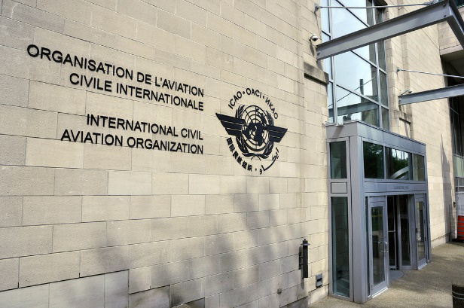
The ICAO Council is the main organ of the organization and adopts standards and recommended practices (SARPs) concerning air navigation, its infrastructure, flight inspection, prevention of unlawful interference, and facilitation of border-crossing procedures for international civil aviation. ICAO defines the protocols for air accident investigation that are followed by transport safety authorities in countries signatory to the Convention on International Civil Aviation.
Image 1: ICAO Headquarters located in Montreal
In the early 20th Century, the International Telecommunication Union met to discuss and implement one of the first internationally agreed upon standards relating to aviation, country-specific prefixes for aircraft callsigns. The first convention was held in 1903 in Berlin, Germany, but no agreements were reached among the eight countries that attended. At the second convention in 1906, also held in Berlin, twenty-seven countries attended. The third convention, held in London in 1912, allocated the first radio callsigns for use by aircraft. Following this, at the Paris Convention of 1919, a forerunner to ICAO named ICAN was established, the International Commission for Air Navigation. ICAN continued to operate until 1945.
The Convention on International Civil Aviation, also known as the Chicago Convention, was signed by 52 countries on 7 December 1944. Under its terms, a Provisional International Civil Aviation Organization was to be established, to be replaced in turn by a permanent organization when twenty-six countries ratified the convention. PICAO began operating on 6 June 1945, replacing ICAN. The 26th country ratified the convention on 5 March 1947 and, consequently, PICAO was disestablished on 4 April 1947 and replaced by ICAO, which began operations the same day.
As of currently, there are 193 ICAO members, consisting of 192 of the 193 UN members (all but Liechtenstein, which lacks an international airport), plus the Cook Islands.
Despite Liechtenstein not being a direct party to ICAO, its government delegated Switzerland to enter into the treaty on its behalf, and the treaty is applicable in the territory of Liechtenstein.

ICAO’s Rulemaking Process
The International Civil Aviation Organization, like other UN assemblies or organizations (except for the Security Council), does not engage in binding rulemaking itself, instead developing standards and delegating enforcement and implementation to its several Member States. Rulemaking is most commonly done as SARPs, Standards and Recommended Practices. In addition to the SARPs, ICAO publishes Final Reports, accident investigation reports written by Member States’ civil aviation authorities when an aircraft is involved in an accident within their territory or airspace.
It is therefore important for delegates to keep in mind that they should seek to compromise and work together, as ICAO standards are only enforceable if the wider global community has faith in the rulemaking process.

Historical Context

Aviation in the 1980s
The 1980s were characterized by a distinct lack of integration in the aviation sector due to the Iron Curtain. Although the International Civil Aviation Organization (ICAO) functioned as a regulatory framework for global standards, its efficacy was frequently curtailed by the divergent political and economic objectives of the Western and Eastern Blocs.
In the Western Bloc, the aviation sector was primarily defined by the transition toward market liberalization following the United States Airline Deregulation Act of 1978. This prioritized the optimization of commercial efficiency, competition, and the development of fuel-efficient airframes by manufacturers such as Boeing. Conversely, the Eastern Bloc maintained a centralized, state-controlled model. In the Soviet Union, Aeroflot operated as a state monopoly with significant military integration. Aeronautical engineering in the East, led by state enterprises such as Tupolev and Ilyushin, prioritized mechanical durability and operational capability in underdeveloped infrastructure over the commercial comfort and economic performance benchmarks favored in the West.
Navigation in the1980s lacked the precision of today’s modern satellite-based systems. In the absence of GPS, aircraft relied upon Inertial Navigation Systems (INS) and ground-based navaids. These systems were affected by inaccuracies, or "drift," which required constant manual monitoring by flight crews. The limitations of these technologies, coupled with the rigid enforcement of prohibited airspaces, led to significant and safety crises.
Furthermore, the safety and security protocols of the 1980s were rudimentary by contemporary standards. The industry was only starting to implement strategies such as Crew Resource Management (CRM) to mitigate human error within hierarchical command structures. Most modern safety systems were either in their infancy or did not exist yet at all. Consequently, the ICAO was tasked with managing a high-risk environment characterized by technical limitations and frequent state-sponsored interference. For the purposes of this committee, it is essential to recognize that the 1980s represented a period where technical standardization was secondary to the maintenance of sovereign territorial integrity and ideological compartmentalization.

Reagan Administration
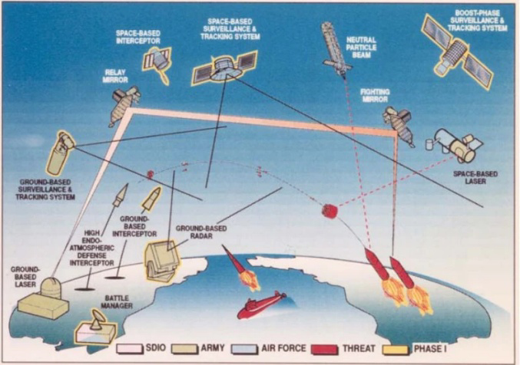
President Ronald Reagan, elected in 1980, was the 40th President of the United States, and had a tough view regarding communism. Unlike his predecessors, he was against the policy of détente (easement of tensions) and immediately started to sway the American foreign policy against the USSR.
In his talk in 1983, he famously called the USSR “the evil empire”. In the continuation of his speech, he said: “I ask you to resist the attempts of those who would have you withhold your support for our efforts, this administration’s efforts, to keep America strong and free (…)”
He also initialized the Strategic Defense Initiative (SDI). The Plan, nicknamed by the public as “Star Wars”, included a space defense system which would intercept any Soviet intercontinental ballistic missile while in space. The plan would have been expensive, estimated to cost around 70 billion USD (1983 estimate) and was considered by many on both sides of the aisle to not be worth the cost.
Image 2: Concept Image of Phase 1 of Space Defense Initiative (SDI)
Reagan’s antagonizing policies didn’t stop at these. His administration also commissioned the Pershing II missiles, and shipped them into Western European Countries, where they would be able to reach Moscow in minutes. His administration also conducted US Naval Exercises near the Soviet mainland (e.g., Sea of Okhotsk), possibly testing Soviet radar capabilities.
He also introduced the Reagan Doctrine, which said that United States government would back any anti-communist militias, parties and threats to any communist government. The administration did this in countries such as Afghanistan, Nicaragua, Angola, Poland.
In general, the Reagen administration was known to be one of the toughest administrations when it came to anti-Soviet policy.

Soviet Regime
At the time, the General Secretary of the Union of Soviet Socialist Republics was Yuri Andropov. He had risen to the position after the death of Leonid Brezhnev in 1982. He was the head of KGB for 15 years prior to his assuming of the position. He had assumptions that the West had plans of a “decapitation strike0F”.
His short reign was marked by a push of “Iron Discipline”, a policy which aimed to tackle corruption and raise the discipline throughout the Soviet people.
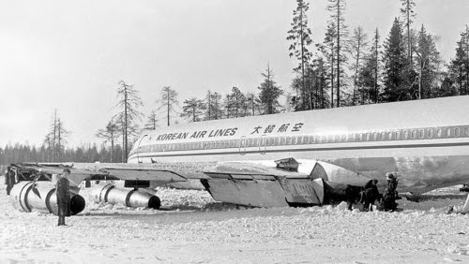
Prior to his rise, in 1981, the Soviet Union launched Operation RYAN (Raketno-Yadernoye Napadenie – lit. “Nuclear Missile Attack”), which had the aim of monitoring every activity of the United States which could trigger World War III.
It would later contribute to the shootdown of Korean Air Flight 007, since it was procedures and increased surveillance resulting from procedures of Operation RYAN that led to the aircraft being noticed and promptly shot down.
Image 3: Korean Air Flight 902 (Shot down in 1978) crash site
Additionally, the airspace Korean Air Flight 007 was shot down above was one of the most sensitive regions in the country, since it housed Soviet Nuclear ballistic missile submarines. The Soviets also had their suspicions that the United States was actively testing Soviet radar capabilities and map their radar signatures via civilian looking aircraft. It also didn’t help that the United States was conducting naval exercises at the Sea of Okhotsk.
Finally, the Soviet Air Force (PVO) had a policy of “zero tolerance” and was also criticized in 1978 due to their slow response at Korean Air Flight 902 (which had also violated Soviet airspace and was shot down, though it did not suffer rapid hull loss.)
Throughout this era, Soviet administrations were always closed off and distant to western countries.

Incident: Korean Air Flight 007

Initial Flight
KAL 007 was a scheduled passenger flight, operated by a Boeing 747-230B registered as HL7442, from Anchorage, United States (ANC) to Seoul, Republic of (South) Korea (SEL). According to its submitted flight plan, the aircraft was supposed to fly via the R20 airway from Bethel VOR1F.
After departure, Flight 007 went onto a heading of 220°. ATC then instructed the crew to proceed direct to Bethel VOR (BET). Normally, the crew would have been able to rely on the VOR Anchorage (ANC) as well, but this navaid was unavailable at the time of the accident. The crew were aware of this INOP navaid by way of the NOTAM.
The Boeing 747 has 4 lateral autopilot modes, these are:
- HEADING: Aircraft follows the entered magnetic heading.
- VOR/LOC: Aircraft follows the course entered by the crew to the entered frequency corresponding to a VOR or Localizer.
- ILS: Aircraft follows the entered frequency corresponding to ILS both laterally and vertically.
- INS: Aircraft follows the pre-programmed route. For this mode to work in “active” mode aircraft must be on a course to intercept the route and must be at most 7.5 nautical miles away from the route. Otherwise system will remain in “armed” mode and aircraft will keep flying the last assigned heading unless both conditions are met at a future time.
After the aircraft reached Bertel VOR (according to U.S. military radar, the aircraft was actually 12 miles north of the navaid), the INS mode should have been engaged. According to ICAO simulations, the pilots either didn’t turn on the INS mode, or they did but aircraft was unable to switch from “armed” mode to “active” mode. It is believed to be that no one at any radar station believed the deviation as being more than the INS’s own fault rate (which was 2 miles) and as such, no one warned the crew.
Since the aircraft was not at its expected position, the crew had problems using VHF (very-high frequency) radio and had to relay their communications via another aircraft just to talk with ground radar. Later they used HF (high frequency) radio to talk to the ground (which can be utilized over long distances but has poor audio quality). Neither the crew nor the ground staff thought this was unordinary.

Deviation and Shoot-down
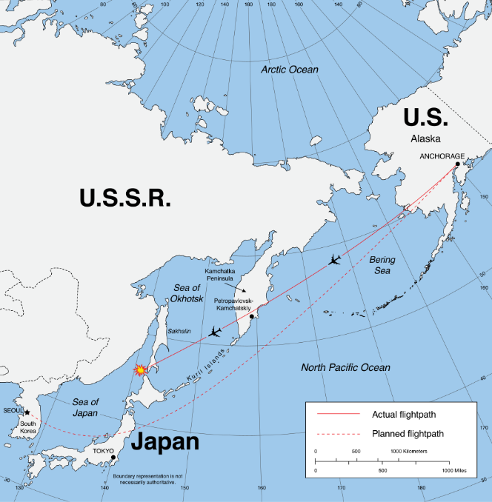
The aircraft continued to cross the Pacific but deviated more during the flight. While Flight 007 was nearing the Soviet mainland, the Soviet military was on high alert since they were going to test their ballistic missile at the Kura Missile Test Range. A United States Air Force RC-135 was also in the vicinity on a reconnaissance mission.
According to Soviet authorities, Korean Air Flight 007 entered the restricted zone that extends to 200 nm at 15:51 UTC. The 100-kilometre (54 nm) radius of the buffer zone nearest to Soviet territory had the additional designation of prohibited airspace. When the flight was about 130 km from the mainland, 4 MiG-23 fighter jets took off to intercept the flight. According to Soviet Air Force Captain Aleksandr Zuyev’s statement regarding the event, Soviets were unable to identify the aircraft because 10 days prior to the shoot-down, arctic gales had knocked out the warning radar and the contractor responsible for repairs falsified their records and lied to Moscow.
Image 4: Map of Flight 007’s deviation and intended route throughout the journey.
Meanwhile General Valeri Kamensky (The Commander of the Soviet Far East District Air Defense Forces) and his subordinate General Anatoly Kornukov had a discussion regarding the aircraft which according to Kamensky’s interview is this:
- General Kornukov (to Military District Headquarters-Gen. Kamensky): "...simply destroy [it] even if it is over neutral waters? Are the orders to destroy it over neutral waters? Oh, well."
- Kamensky: "We must find out, maybe it is some civilian craft or God knows who."
- Kornukov: "What civilian? [It] has flown over Kamchatka! It [came] from the ocean without identification. I am giving the order to attack if it crosses the State border."

Soviet interceptors had been tracking the Boeing 747 since it first entered their airspace. The 747 briefly exited Soviet airspace over the Sea of Okhotsk before re-entering near the highly militarized Sakhalin Island. Completely unaware of the trailing interceptors, the flight crew contacted Tokyo ATC and requested a climb to a higher altitude to improve fuel economy.
Tokyo ATC granted the request, which sealed the aircraft's fate. Already suspecting the plane was an American intelligence aircraft, Soviet commanders interpreted this sudden deceleration and climb as an evasive maneuver and ordered it shot down. The Su-15 interceptor aircraft fired two air-to-air missiles; one detonated just behind the tail, sending shrapnel through the fuselage, severing elevator control cables, and causing rapid decompression and hull loss.
Despite the damage, the 747 did not immediately break apart. Instead, the severed flight controls caused the nose to pitch upward, causing pitch and yaw oscillations. The aerodynamic stress and overspeed conditions of the descent tore the airframe apart in mid-air before it crashed into the Sea of Japan.
The exact location of the attack became a point of contention. Investigations indicated the missiles were fired as the aircraft was crossing back into international airspace, though Soviet officials deny this, claiming the aircraft was engaged in an espionage mission and was in Soviet airspace as it was shot down.

Aftermath

United States
US President Ronald Reagan took a very aggressive stance following the incident, utilizing the tragedy to highlight the ideological divide of the Cold War. In a nationally televised address, he described the shoot-down as a "massacre" and a "crime against humanity that must never be forgotten." The U.S. administration focused on the fact that the aircraft was clearly civilian, arguing that no civilized nation would fire upon an unarmed passenger plane regardless of where it had been flying.
The United States took the lead in the international diplomatic offensive that followed. The US presented intercepted audio recordings of the Soviet pilot to the United Nations Security Council. These tapes, which recorded the pilot saying "the target is destroyed," were used to prove that the Soviet military had made no effort to identify the plane or warn the crew of their airspace violation.

Soviet Union
The Soviet Union's response evolved from initial silence to a fierce defense of their actions. After five days of denying any knowledge, the Kremlin issued a statement through the TASS news agency claiming that the flight was a "pre-planned intelligence operation" by the United States. They argued that the Boeing 747 was specifically sent to fly over sensitive military installations on Sakhalin Island to trigger Soviet radar systems so that a nearby U.S. RC-135 spy plane could record the responses.

Marshal Nikolai Ogarkov, the Chief of the General Staff, held a televised press conference for domestic and international media. He used large maps to argue that the aircraft was flying with its lights off and was not responding to radio calls. The Soviet position was that their territory is sacred, and their military has a duty to defend the borders against any "intruder" that refuses to identify itself, especially in a region housing nuclear submarines and strategic bases.

Republic of Korea
In 1983, the Republic of Korea did not yet have formal diplomatic relations with the Soviet Union and was not yet a member of the United Nations. As a result, the South Korean government lacked a direct communication channel with Moscow and had to rely on the United States and Japan to represent its interests. South Korea utilized the ICAO Council as its primary international platform to demand a formal investigation and to challenge the Soviet Union’s claims regarding the aircraft's mission.
The South Korean administration focused on three main objectives: the return of the aircraft’s flight data recorders (black boxes), the recovery of the victims' remains, and a detailed explanation of the shoot-down. Korean government formally disputed the Soviet "spy plane" narrative, stating that KAL 007 was a registered commercial flight following a scheduled civilian route. Despite these demands, the Soviet Union initially denied the Korea’s and international investigators access to the suspected crash site near Moneron Island.

Japan
The Japanese Self-Defense Forces monitored the radio communication exchanges between the Soviet pilot and his controller through their monitoring station in Wakkanai. The Japanese government presented these audio recordings to the UN Security Council, providing vital technical proof to aid the inquiry. These audio recordings played an important role in recording the communication exchanges that took place during the interception operation.
Japan spearheaded the international search and rescue mission in the Sea of Japan. In the course of these missions, there were operational conflicts between the Japanese ships and Soviet naval forces regarding the discovery of the crash site and the black box recorder. The Japanese government urged the need to upgrade radar tracking technology and military interception procedures along North Pacific air corridors.

Legal Framework
The Chicago Convention, signed on December 7, 1944, is the convention that incorporated civil aviation throughout the world and would later lead to the founding of International Civil Aviation Organization.
The Convention has annexes. One of them being Annex 2 – Rule of Air. Annex 2 states the rules that apply to all civilian aircraft all around the world. These rules ensure that flight operations are conducted in a safe and orderly manner.
Annex – 2 defines rules of engagement such as rocking the wings meaning “You are intercepted, follow me.” And requires the intercepted aircraft do the same to acknowledge. Or provides 121.5 MHz channel which can be used in emergencies and must always be listened to by crews all around the world.

Key Terms
Airspace: The portion of the atmosphere controlled by a country above its territory, including its territorial waters.

Inertial Navigation System (INS): A navigation aid that uses computer, motion sensors, and gyroscopes to continuously calculate the position, orientation, and velocity of an aircraft without needing external references.

VHF Omnidirectional Range (VOR): A type of short-range radio navigation system for aircraft, enabling units with a receiving unit to determine their position and stay on course.

Flight Path Deviation: Any unauthorized or accidental change from the pre-defined flight plan or route.

Interception: The act of military aircraft approaching a civilian or unidentified aircraft to identify it or escort it away from restricted areas.

Transponder: An electronic device that produces a response when it receives a radio-frequency interrogation; it helps radar identify an aircraft.

Squawk Code: A four-digit discrete transponder code assigned by air traffic control to identify a specific aircraft on radar.

Flight Data Recorder (FDR): A "black box" device used to record specific aircraft performance parameters to assist in the investigation of aviation accidents.

Cockpit Voice Recorder (CVR): An audio recording device in the cockpit that captures the conversations of the pilots and other sounds for accident investigation.

Secondary Surveillance Radar (SSR): A radar system that relies on a signal transmitted from the aircraft (the transponder) to provide more detailed information like altitude and identity.

Waypoint: A specific geographical coordinate used to define a flight path or navigation route.

Air Traffic Control (ATC): A service provided by ground-based controllers who direct aircraft on the ground and through controlled airspace.

Flight Level (FL): A standard nominal altitude of an aircraft, expressed in hundreds of feet (e.g., FL310 is 31,000 feet).

Autopilot: A system used to control the trajectory of an aircraft without constant "hands-on" control by the pilot.

Heading: The direction in which the nose of the aircraft is pointed, usually expressed in degrees.

Magnetic Drift: The lateral deviation of an aircraft from its intended course due to errors in the navigation system or magnetic variations.

Emergency Frequency (121.5 MHz): The international air distress frequency used by pilots in distress or by intercepting aircraft to establish contact.

Visual Identification (VID): The process where an intercepting pilot manually identifies an aircraft by looking at its markings, livery, and registration.

Rules of Engagement (ROE): The internal directives that guide military forces on when and how to use force during an interception.

Search and Rescue (SAR): The search for and provision of aid to people who are in distress or imminent danger following an aviation incident.

Questions to be Answered
- How could have been the deviation from the planned route have been avoided?
- In what ways could aviation security be improved to prevent similar accidents?
- What should ICAO as a body add to the Chicago Convention?
- Should air reconnaissance missions be banned, and if so, how?
- What other improvements can be made to improve air safety?

Further Reading
https://www.cia.gov/readingroom/docs/CIA-RDP90-00965R000402820015-3.pdf
https://www.britannica.com/event/Korean-Air-Lines-flight-007
https://www.cia.gov/readingroom/docs/CIA-RDP90-00552R000100490002-7.pdf
https://www.faa.gov/sites/faa.gov/files/21_phak_glossary.pdf

A decapitation strike is the act of striking the enemy first to remove their head of government or commander to render them unable to govern.
Please familiarize yourself with aviation terms such as VOR, ILS, airway etc.
Notice to Airmen

